Contents

CHAPTER 1. BEFORE USING DANA MANAGER 1
I. Required Specifications 3

CHAPTER 2. HOW TO INSTALL DANA MANAGER PROGRAM 4
I. Installment of DANA Manager 4
1. Installment Process 4
II. Installment of Bluetooth 5
III. Connection Setting Between PC and DANA Insulin Pump 6
1. Connection Process 6

CHAPTER 3. FUNCTION 10
I. Registration 10
1. Registration Process 10
II. Connection 11
1. Connection Process 11
III. Blood Glucose 13
1. Blood Glucose 13
2. Standard Day 13
3. Combination 14
4. Blood Glucose(Pie) 15
IV. Insulin 16
1. Daily Total Dose 16
2. Insulin Trend 16
3. Bolus Dose 17
4. Day by Day 18

V. History 19
1. Alarms 19
2. Blood Glucose 19
3. Bolus 20
4. Basal 21
5. Carbohydrate 21
6. Daily Total 22
7. Suspend 23
8. Daily Overview 23
9. Log Book 24

CHAPTER 4. MENU BAR 26
I. Patient 26
1. New 26
2. List 26
II. Insulin Pump 27
1. Disconnect 27
2. History Download 27
3. Pump Status 28
4. Setting 28
5. Bolus 31
III. Chart 34
1. Blood Glucose 34
2. Insulin 35
IV. Insulin 35
1. History 35
2. Upload 35
V. Exit 35

Chapter1. Before using dana manager

I. Required Specifications

- IBM-compatible PC running Windows XP, Windows Vista, and Windows 7.
- One available USB
- 40MB free hard disk space
- Minimum 64MB RAM for Windows
CHAPTER 2. HOW tO INSTALL DANA MANAGER PROGRAM
- Installment of DANA Manager
DANA Manager program will automatically run when the installation CD is inserted.
* In case the auto run was not executed, double click setup.exe file in the CDROM drive to execute.

- Installment Process
- Initiate DANA Manager Installation Wizard
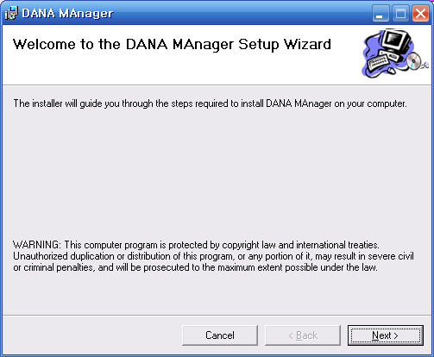 | Click “NEXT” button and start set up.
- Select set up folder
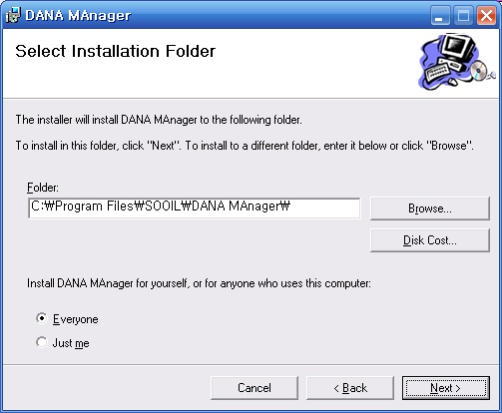 | Select folder where the installation program to be installed and click “NEXT” button.
- Installation
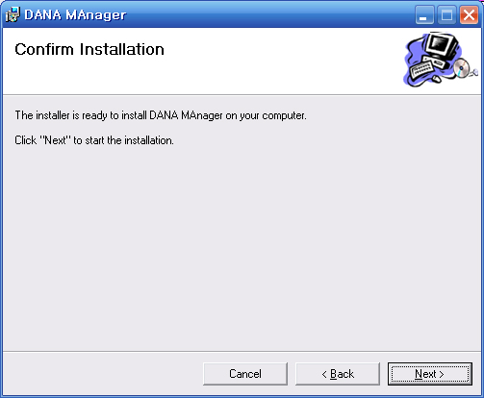 | When you confirmed to install, click “NEXT” button to start installation.

- Set up DANA Manager
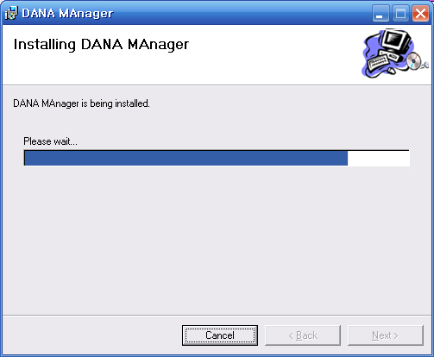 | Installing is being processed. Set up will take about 10-20 seconds.
- Installation Complete
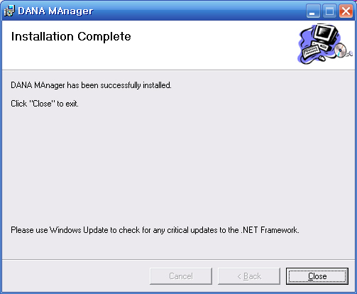 | When the program is been installed, click “ Close” button to finish the installation process.

- Installment of Blutooth
In case the Bluetooth is not installed in the pc, insert a Bluetooth dongle to USB port of your PC or laptop.
Please refer to the user manual or install CD of Bluetooth for detailed information of Bluetooth device.
- Connection setting between PC and DANA insulin pump with Bluetooth
Connect PC and DANA insulin pump. This procedure is required at once for each following cases.
- At the firt time to communicate with PC.
- In case the previous communication information in the PC was deleted.
1. Connection Process
- Execute ‘Bluetooth Unit’ and go to “Control Panel” in your PC. You can find the Bluetooth icon. Please double click it.
- Add ‘Bluetooth Unit’
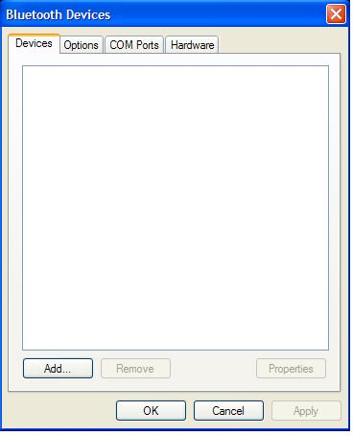 | Click ‘Add’ button on the unit tap to execute wizard of add bluetooth unit.

- Set waiting mode of DANA insulin pump
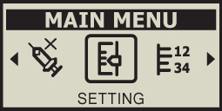  (figure 1)  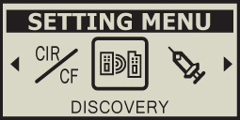  (figure 2)    (figure 3) | This is the procedure to keep DANA pump waiting for communicating with bluetooth unit.  a. In the MAIN MENU screen press N until SETTING icon is  highlighted. Then press S. (figure 1)  b. The SETTING MENU screen will appear. Use N to highlight to DISCOVERY icon and press S (figure 2)  c. Discovery Icon blinks about 60 seconds (figure3)  d. Screen will be changed to initial display once changes saved.

- Inititate the Add Bluetooth Device Wizard
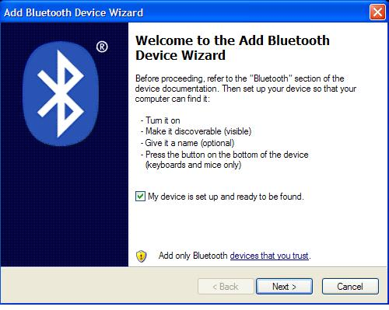 | Tick on ‘Unit set and ready to search’ and click ‘Next’ button.

- Search Unit
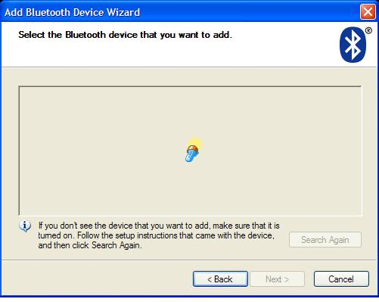 | Searching bluetooth and it takes about 10 -15 seconds.
- Select Bluetooth Unit
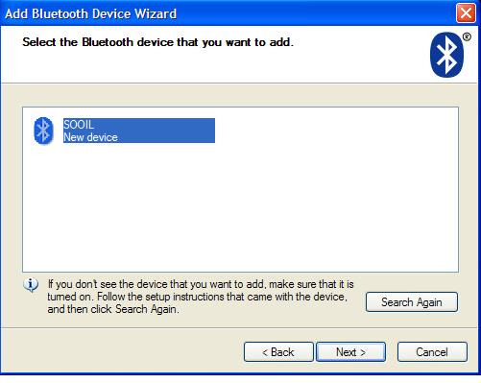 | Insulin pump will be indicated as a serial number.  Add unit and click “NEXT” to continue.  * In case the device is not found, check your insulin pump whether it is in stand by status.  - Check whether or not the wireless option is on in the insulin pump.  - Check whether or not waiting mode to connect, if the wireless option was already on.  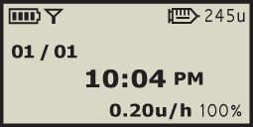  - Insulin pump and remote control must not be connected each other.
- PIN code Set up
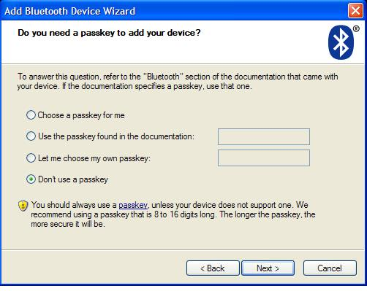 | Select ‘directly select PIN code’  Make the PIN code as ‘0000’.  * In case ‘no PIN code use’ selected, this browser will be dispalyed again. So the PIN code must be set.

- Complete Adding Bluetooth Unit
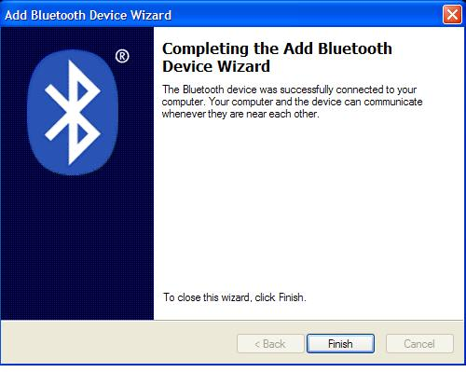 | Add bluetooth unit completed.  Memorise outgoing COM port name.  Click ‘Done’ to finish.
[Note] COM Port Check
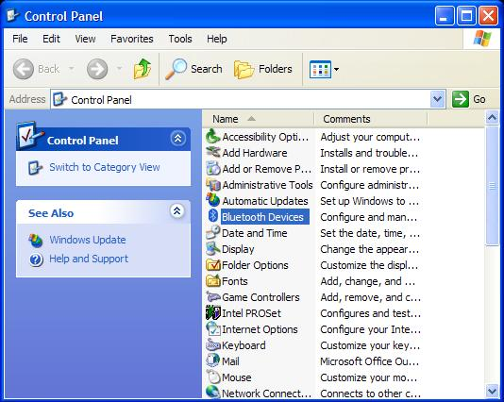 | Doublecheck SOOIL name on COM port.  In case port was not memorised, double click bluetooth unit in the Control Pad to check the outgoing COM port.  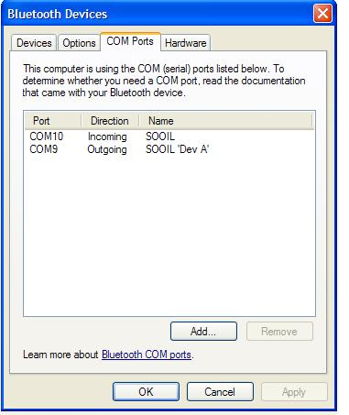
Chapter3. Function

- Registration

- Registration Process
- Click DANA Manager Icon to start it.
- You will see a small pop-up window in the middle of the initial screen.
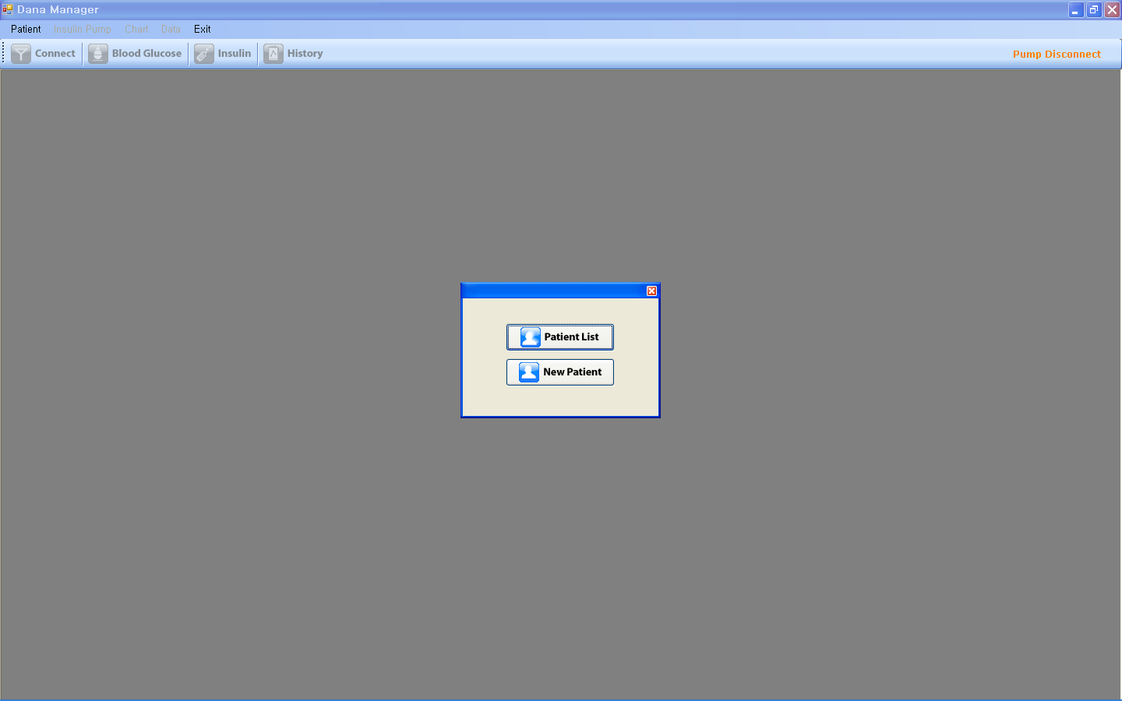

- Please choose between “Patient List” and “New Patient”
- If you choose “New Patient” you will see below screen and you should fill in the required information.
- Serial No should be like “AAA00000AA” using all capital letters
- Input Port number (For example “COM15”)
- Input the patient’s name

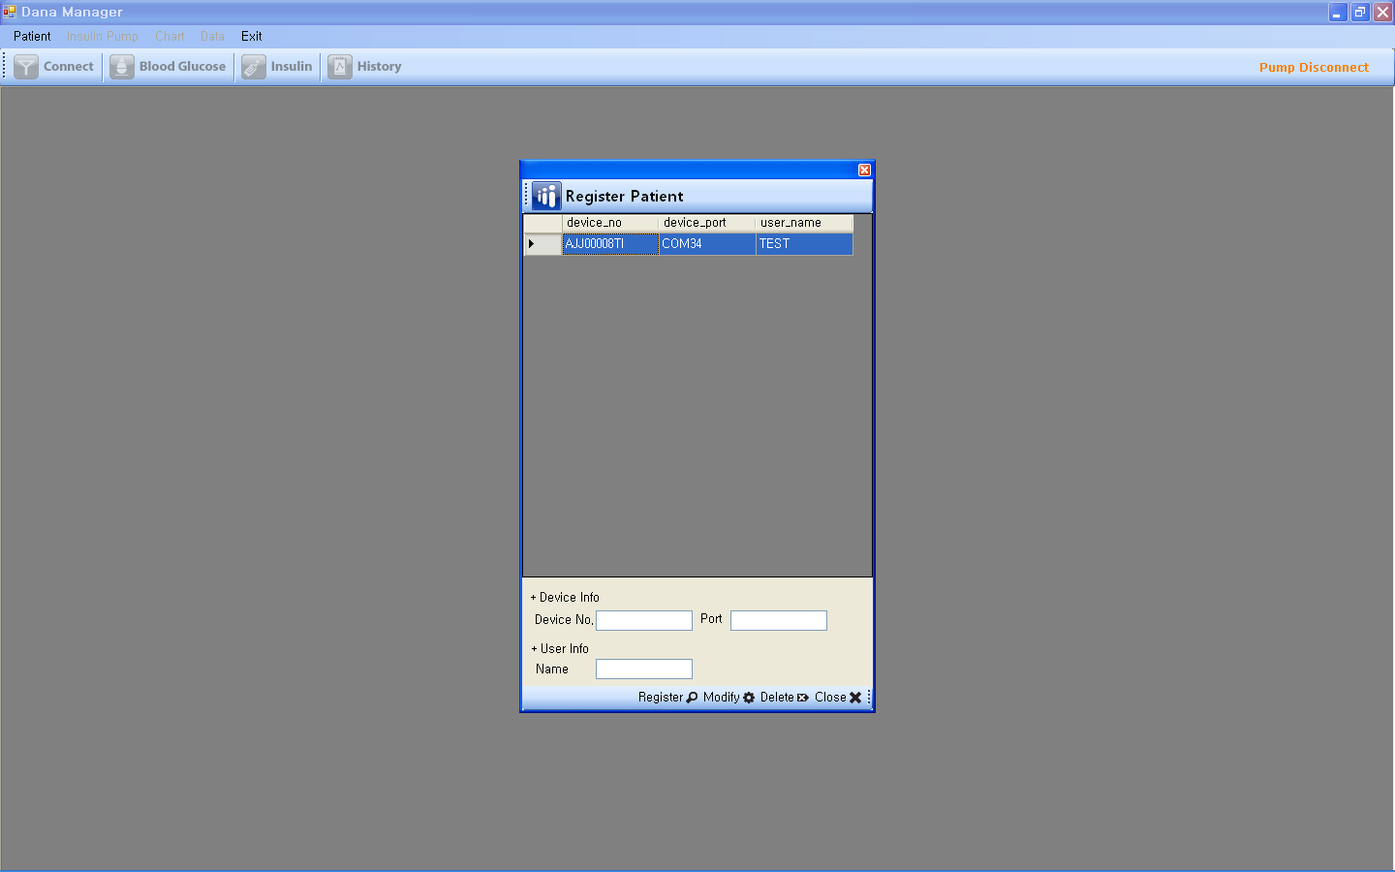

- If you choose “Patient List” please select one of the patient lists.
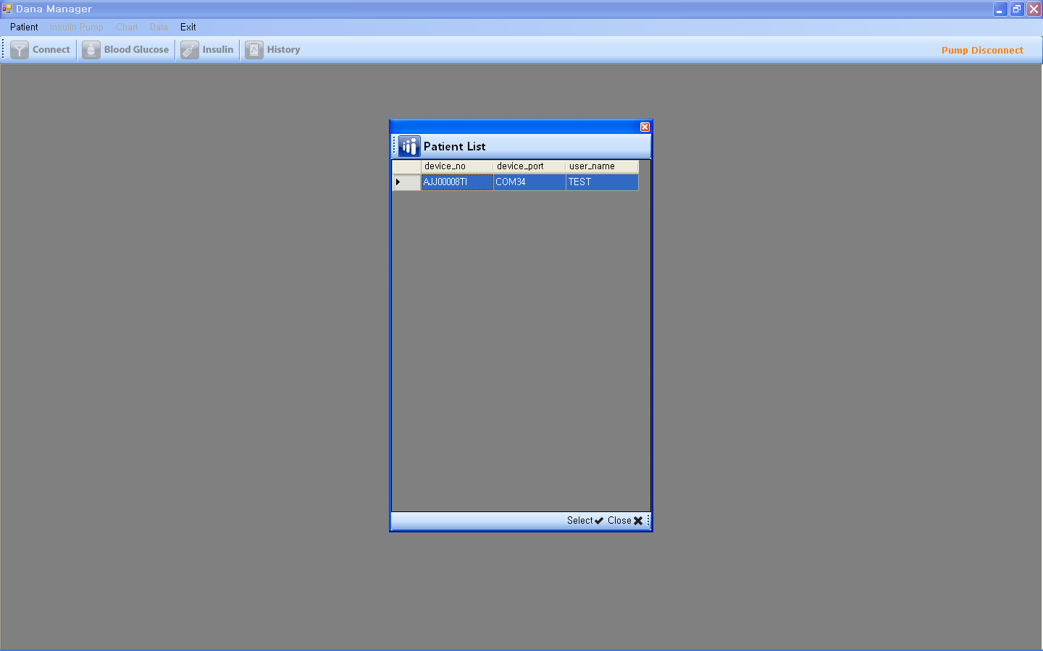

- Connection

- Connection Process
- If you select a patient, you will see the screen below. You can find patient name and serial number in the sub menu bar.
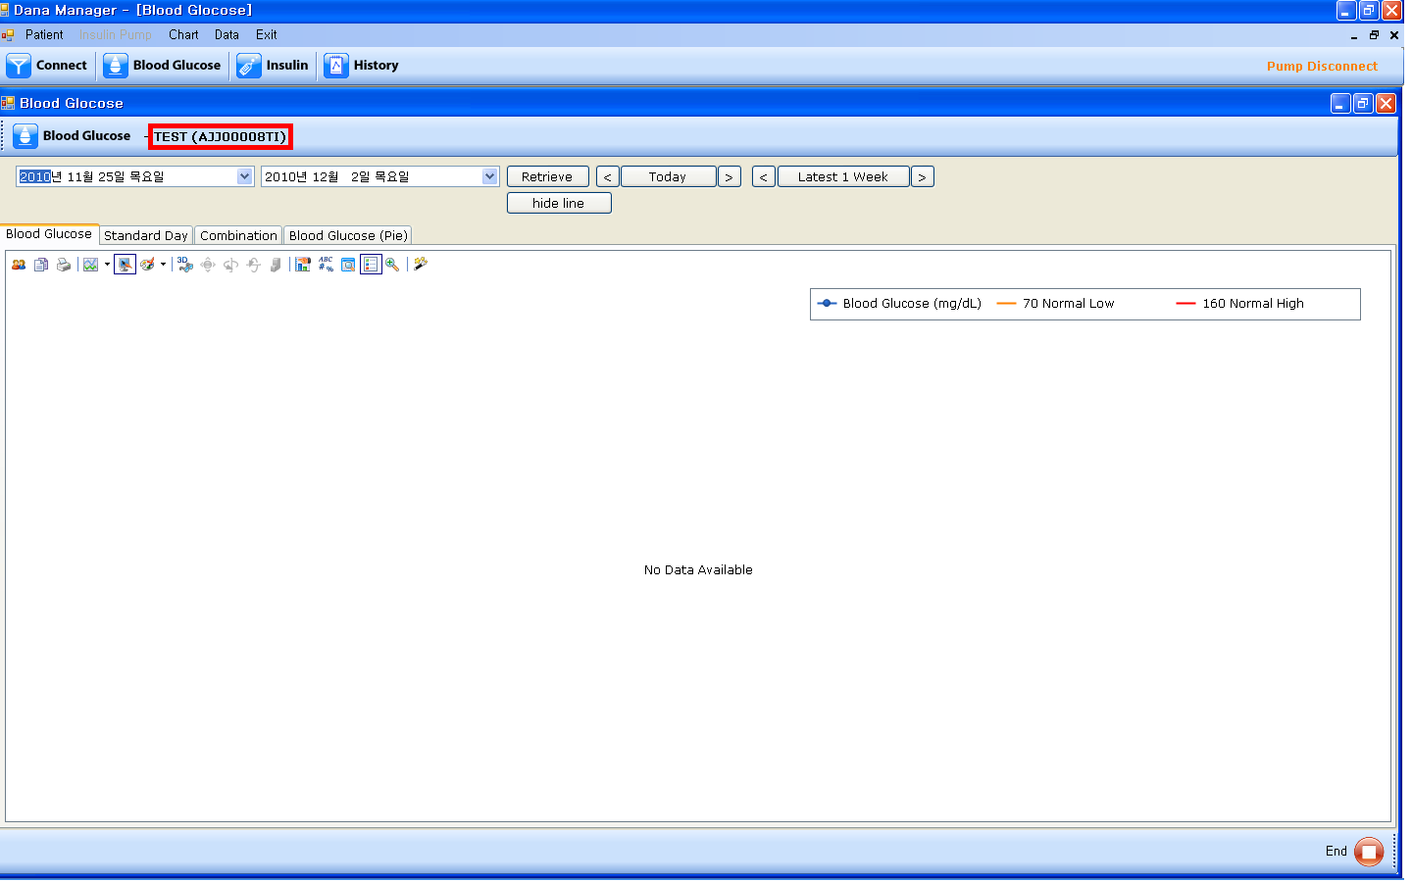

- Please click “Connect” icon. Then your pc and the pump will be connected wirelessly and down load the data from the pump to your pc automatically.
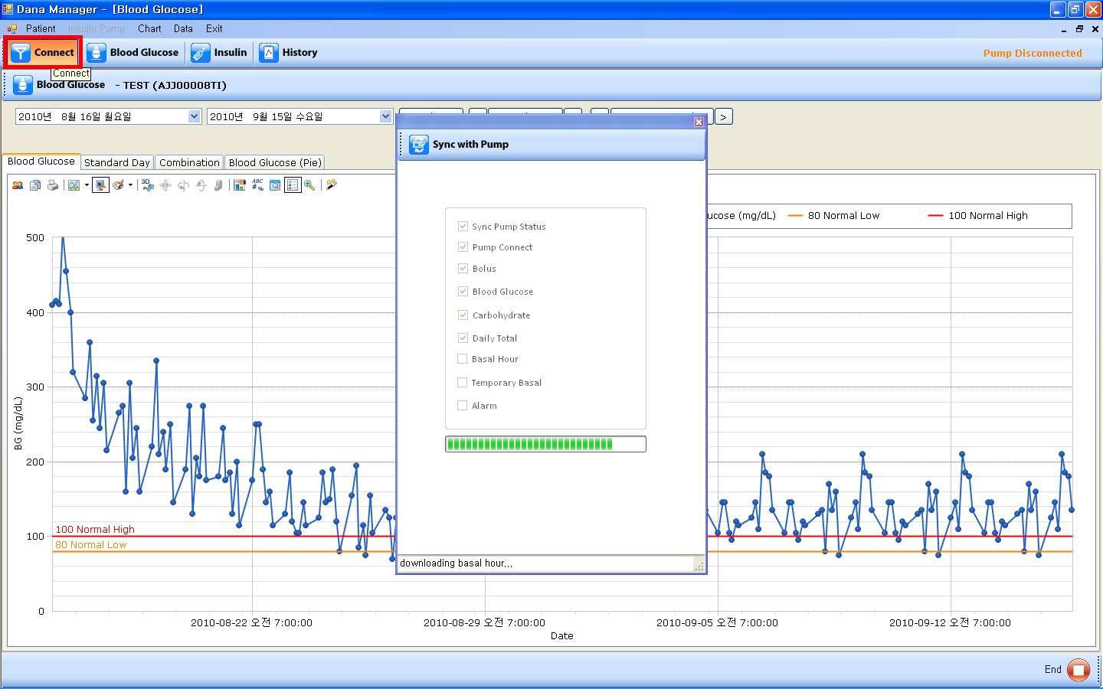

- Blood Glucose
- Blood Glucose
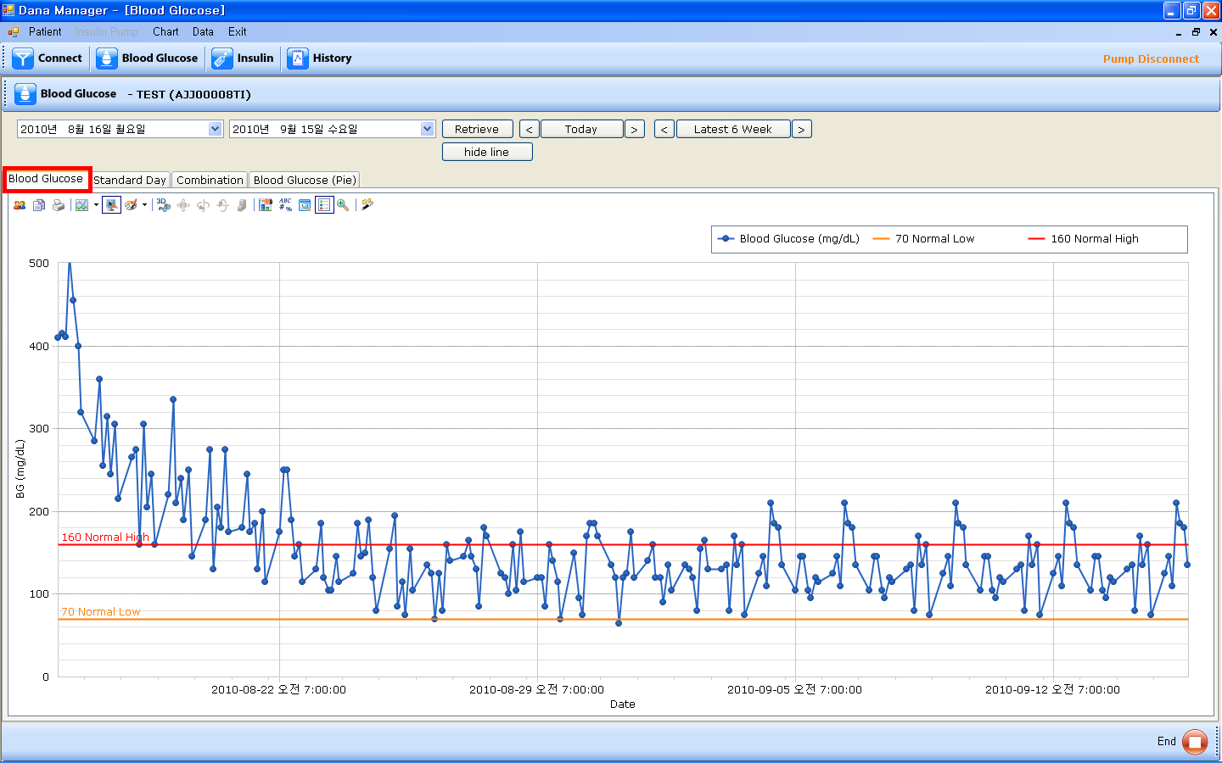

- Blue spots and lines are the blood glucose levels of the patient.
- If you put your mouse pointer on a spot, you will find the detailed information like date, time, and exact blood glucose level.
- You can fine two parallel lines in the screen. One is normal high value line and the other is normal low value line. If you want to change the values of normal high, and normal low, please see Chapter4. MENU BAR > II. Insulin Pump > 4. Setting > C. Normal BG Setting.
- You can adjust the value of them in the “Insulin Pump” menu on the menu bar “Insulin Pump > Setting > Normal BG Setting”. “Insulin Pump” menu is activated when the pump is being connected to your PC.
- You can set the time period by manual or using “Today”, “Last Week”.

- Standard Day
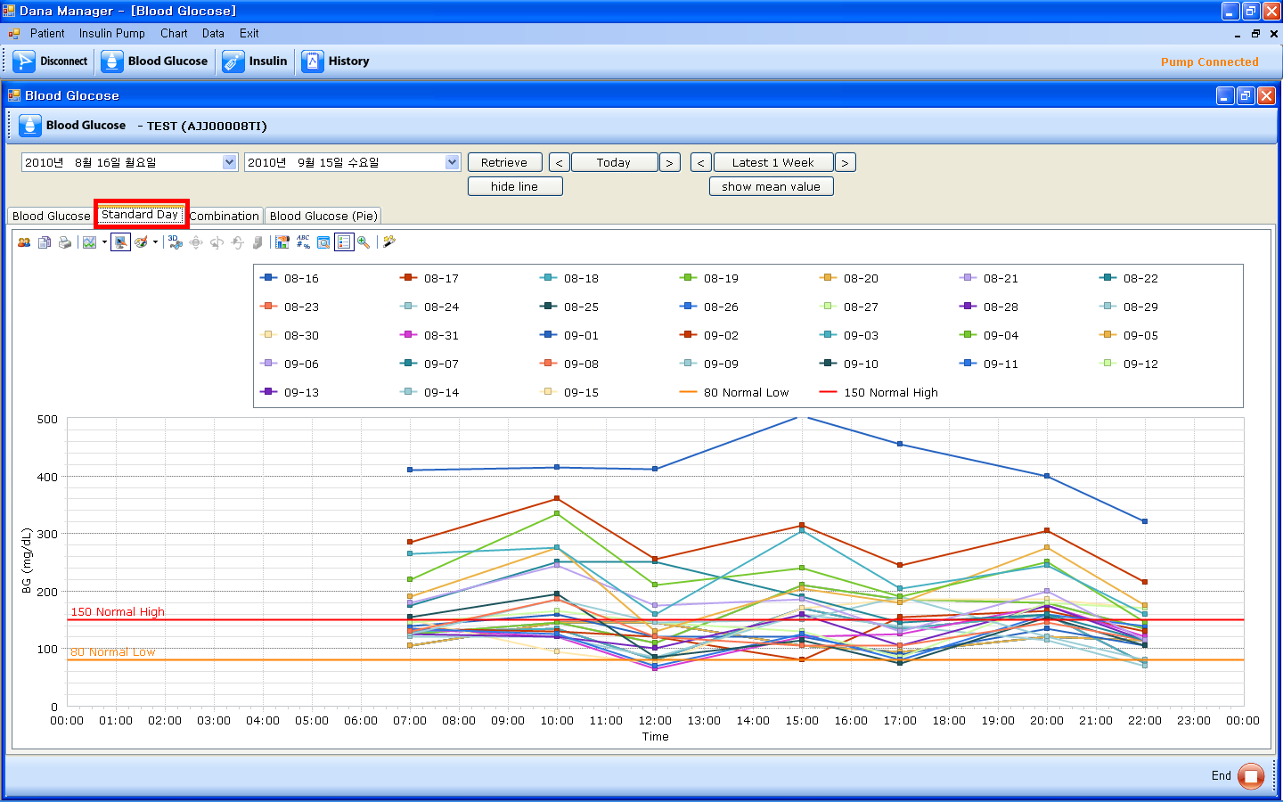

- It is a chart for the evaluation of the change of blood glucose levels by time.
- If you put your mouse pointer on a spot, you will find the detailed information like date, time, and exact blood glucose level.
- If you put your mouse pointer on the specific date in the table, you can see the graph of blood glucose for that specific date only.

- Combination
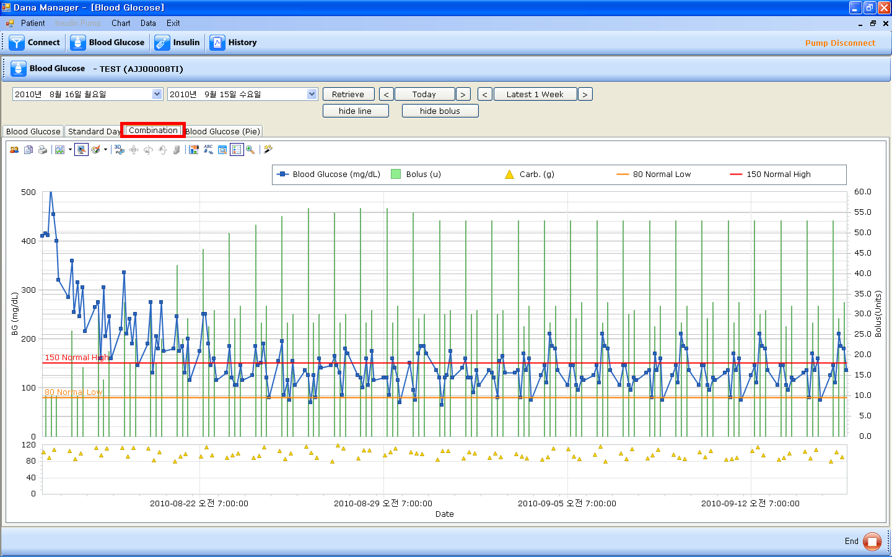

- It’s a combination cart of Blood Glucose, Bolus insulin amount, and carbohydrate amount.
- If you put your mouse pointer on a spot or a line, you will find the detailed information of blood glucose level, bolus amount, and carbohydrate amount with time and date information.
- If you put your mouse pointer on the specific item in the table, you can see the graph for that specific item only.
- Time values are on X-axis, Blood Glucose Values are on the left Y-axis, and Bolus values are on the right Y-axis.

- Blood Glucose(Pie)
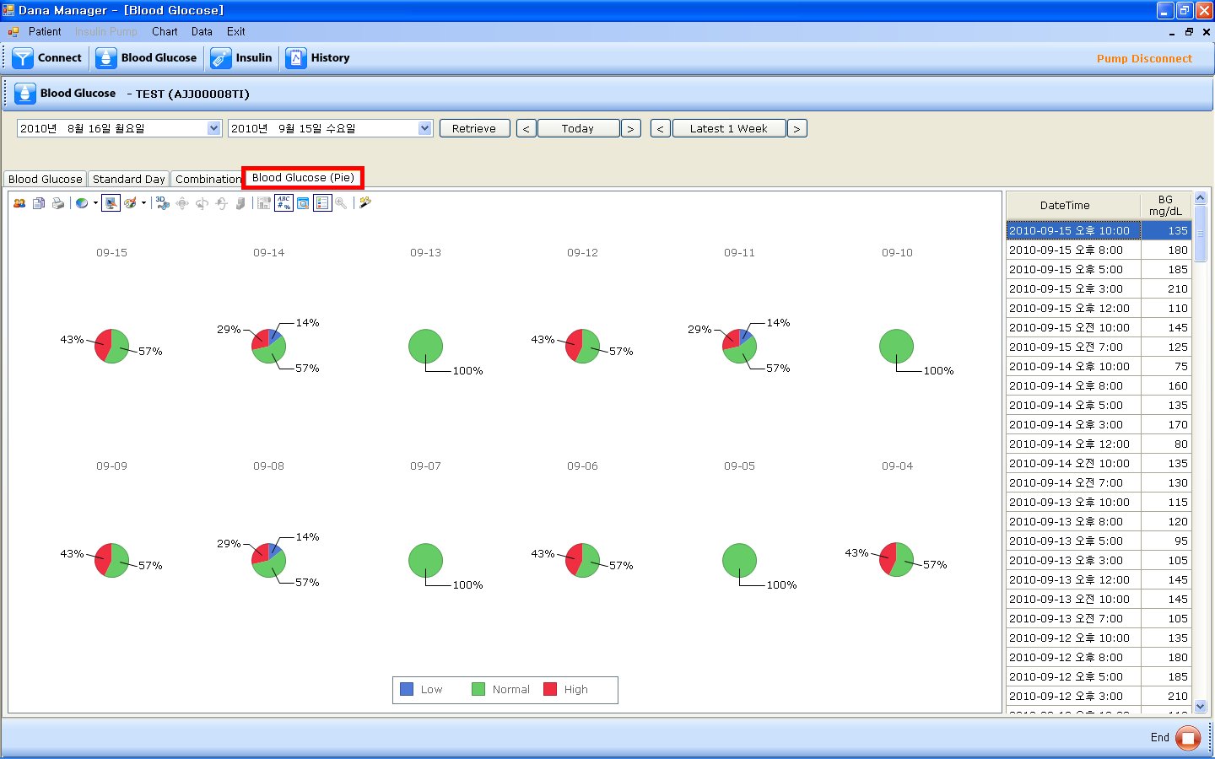

- It is a pie chart for blood glucose levels which are classified according to Low value, Normal value, and High value.
- You can adjust the value for Low, Normal, and High in the “Insulin Pump” menu on the menu bar “Insulin Pump > Setting > Normal BG Setting”. “Insulin Pump” menu is activated when the pump is being connected to your PC.
- If you put your mouse pointer on the specific value in the table, you can see the graph for that specific value only.

- Insulin
- Daily Total Dose
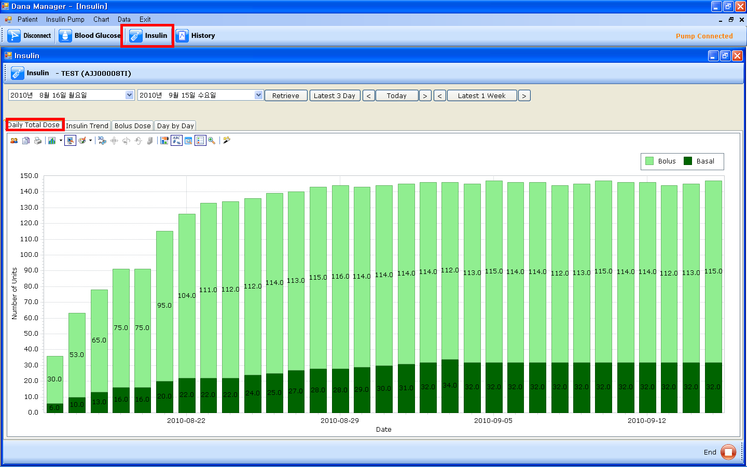
- It’s a bar chart of the total insulin amount divided into Bolus and Basal.
- If you put your mouse pointer on a specific bar, you will find the exact daily total insulin amount on that day.
- If you put your mouse pointer on the specific value in the table, you can see the graph for that specific value only.

- Insulin Trend
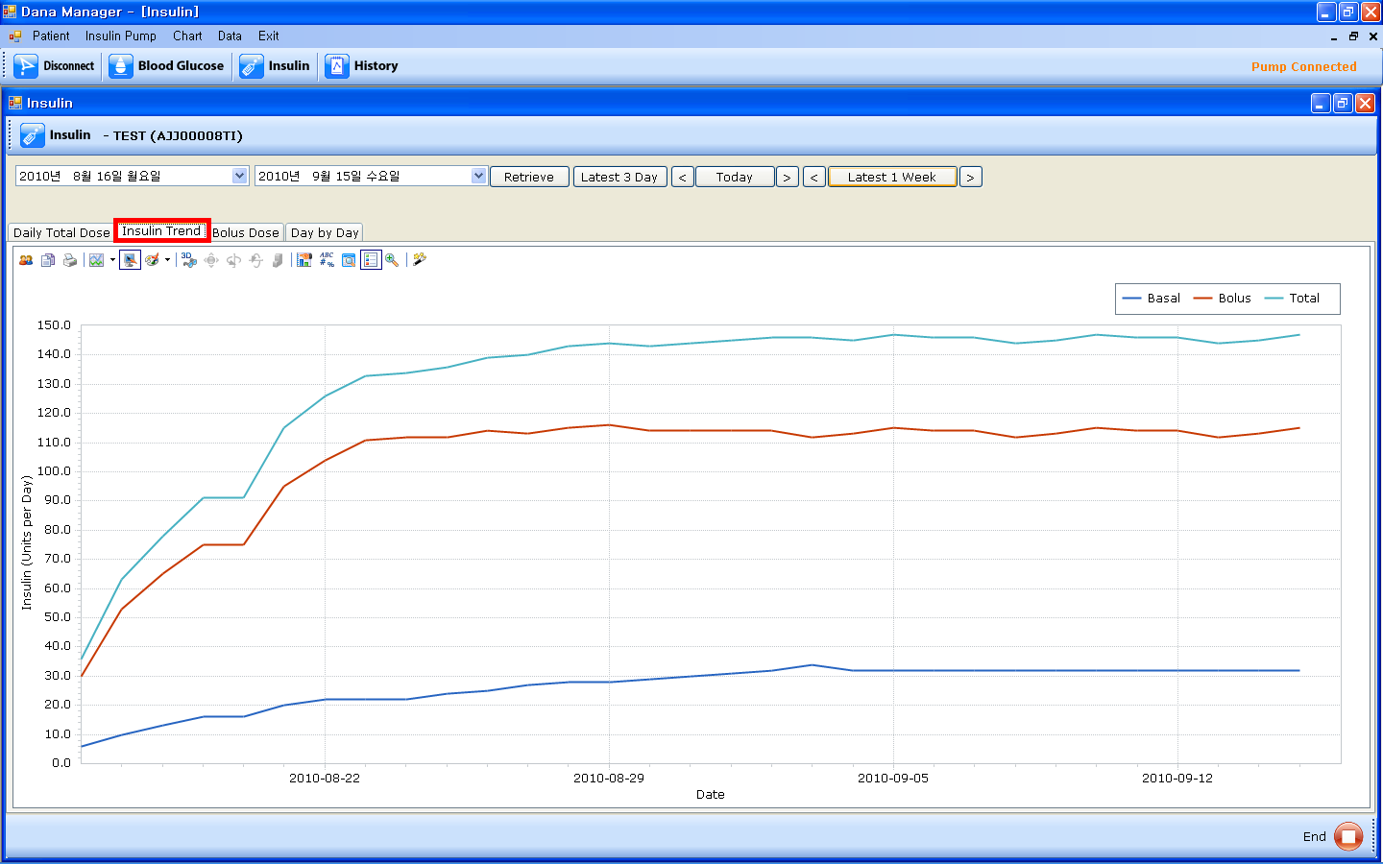

- It’s the line charts of Basal insulin amount, Bolus insulin amount, and Daily total insulin amount.
- If you put your mouse pointer on the specific value in the table, you can see the chart for that specific value only.
- If you put your mouse pointer on the specific line chart, you can see the specific information.

- Bolus Dose
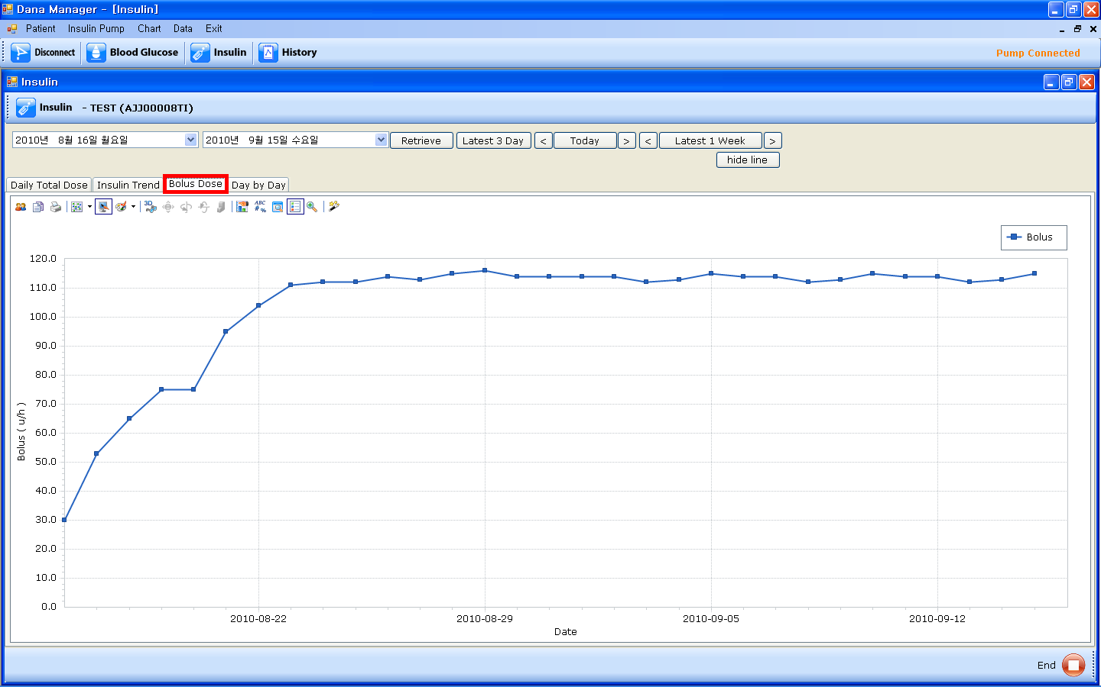

- It’s a line chart of meal bolus insulin amount.

- Day by Day
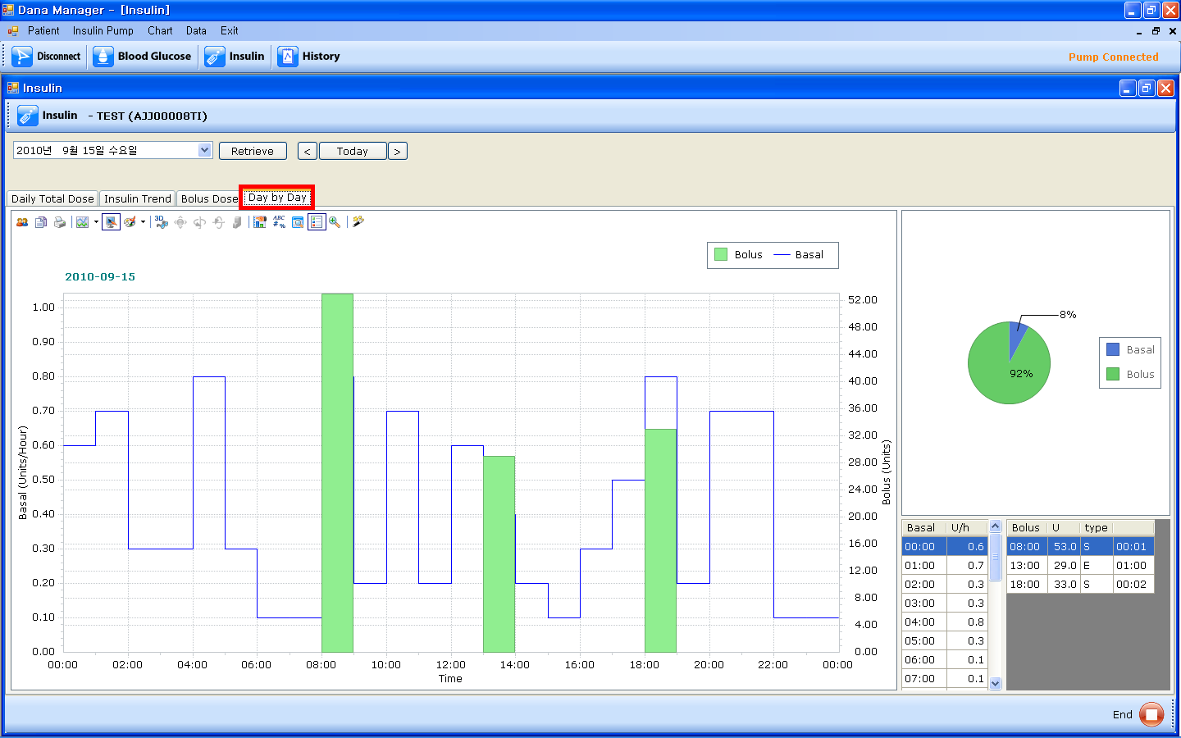
- It’s a combination chart of meal bolus amount and basal insulin amount in a specific day.
- Time values are on X-axis, basal insulin values are on the left Y-axis, and meal bolus values are on the right Y-axis.
- If you put your mouse pointer on the specific value in the table, you can see the chart for that specific value only.
- You can see a pie chart which shows the percentage of basal insulin and bolus insulin out of daily total insulin amount.
- You can also find the detailed tables of basal insulin and meal bolus insulin.

- History

- Alarms
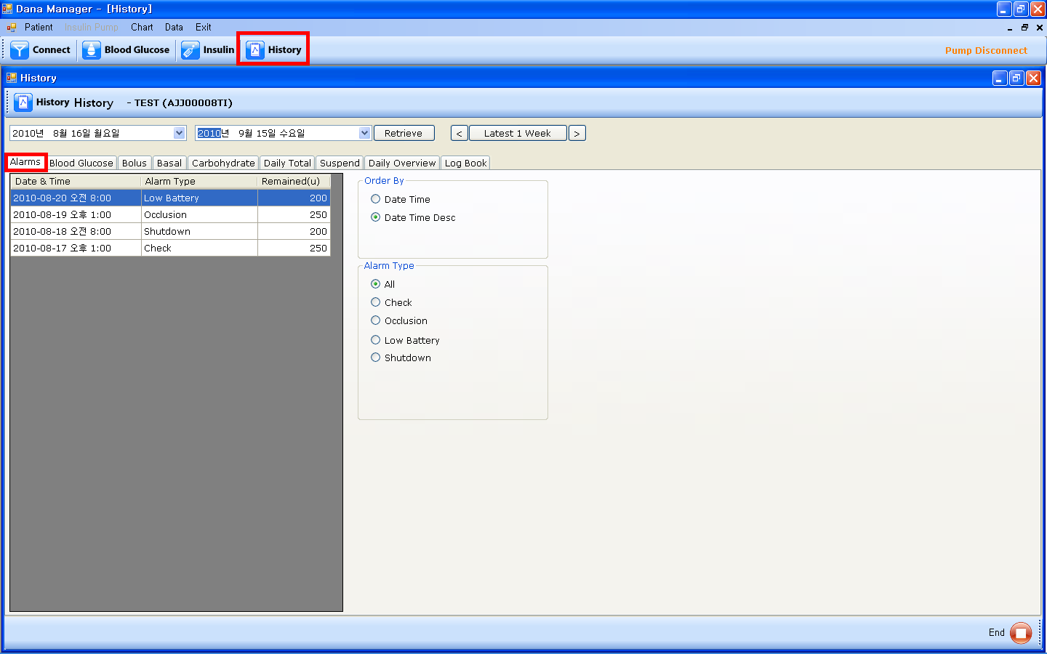

- You can find the history of Check, Occlusion, Low Battery, Shutdown alarms in this menu.
- If you choose “Date Time” in the Order by table, alarms histories will be sorted by date and time in ascending order. If you choose “Date Time Desc”, alarms histories will be sorted by date and time in descending order.
- If you choose a specific value in the Alarm Type table, you can see the specific values which you have chosen.

- Blood Glucose
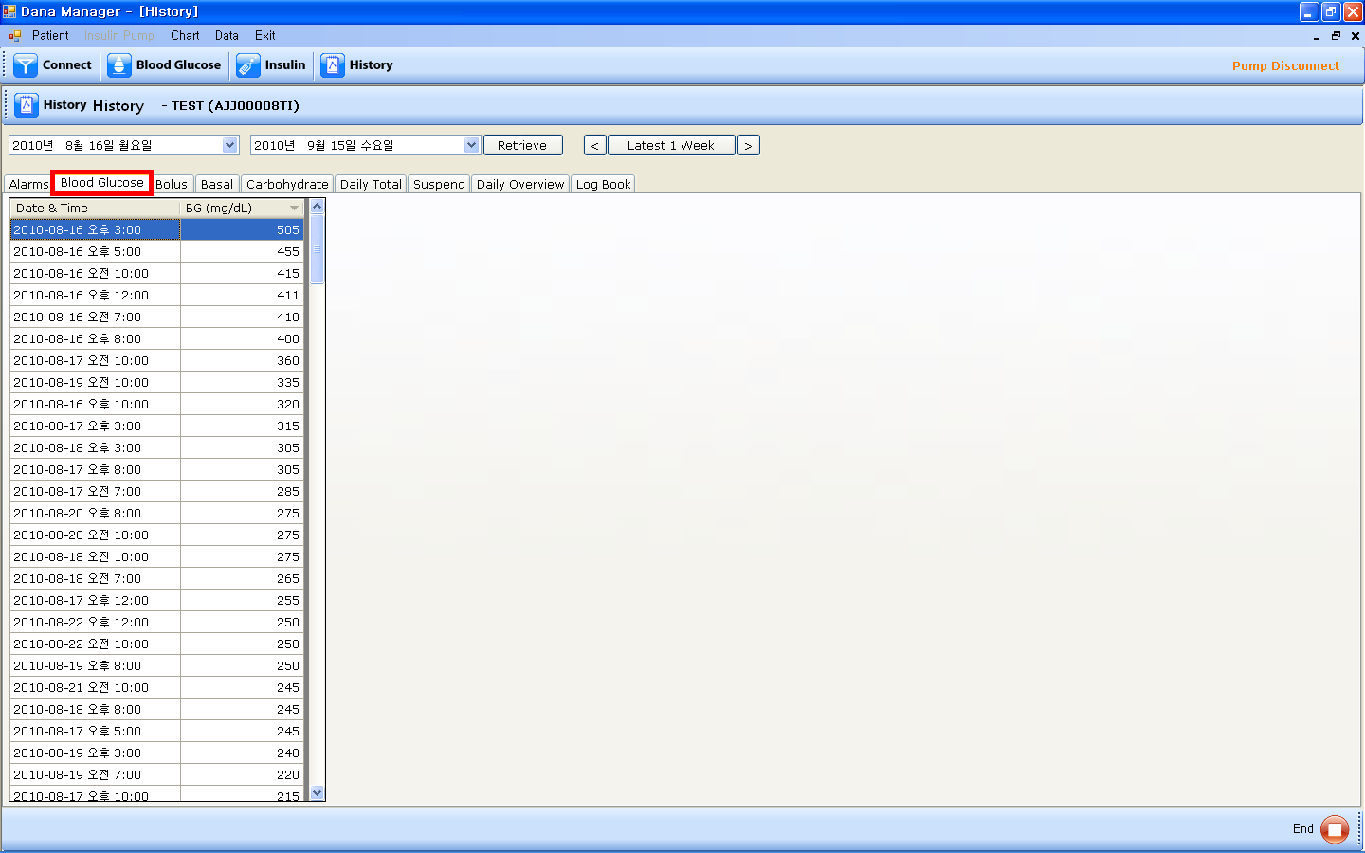

- It’s a history table of blood glucose levels.
- If you click “Date & Time” on the top of the table, the data will be sorted by date and time in descending order.
- If you click “BG” , the data will be sorted by glucose levels in descending order.

- Bolus
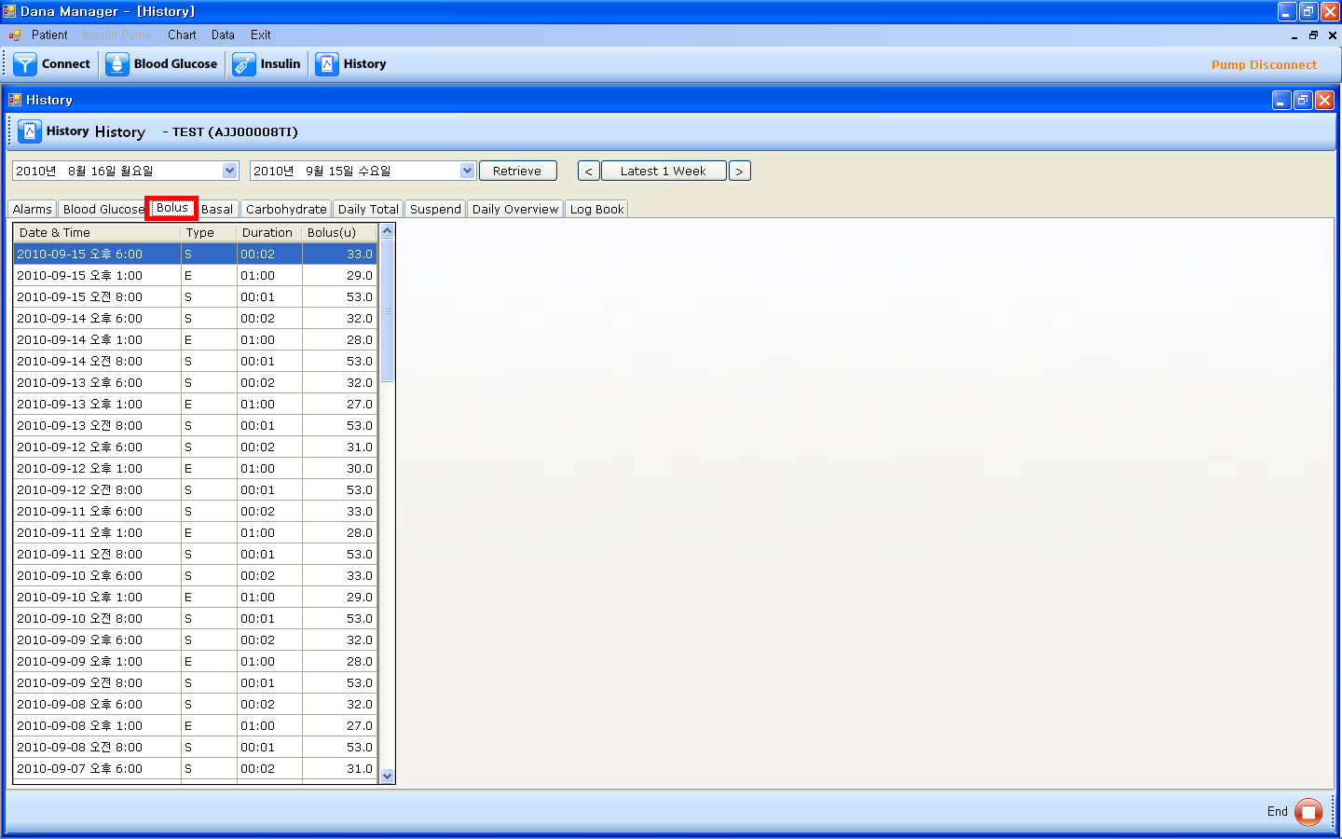

- It’s a history table of meal bolus.
- If you click “Date & Time” on the top of the table, the data will be sorted by date and time in descending order.
- If you click “Type”, the data will be sorted by meal bolus type.
- If you click “Duration”, the data will be sorted by duration of meal bolus in descending order.
- If you click “Bolus(U)”, the data will be sorted by insulin amount in descending order.

- Basal
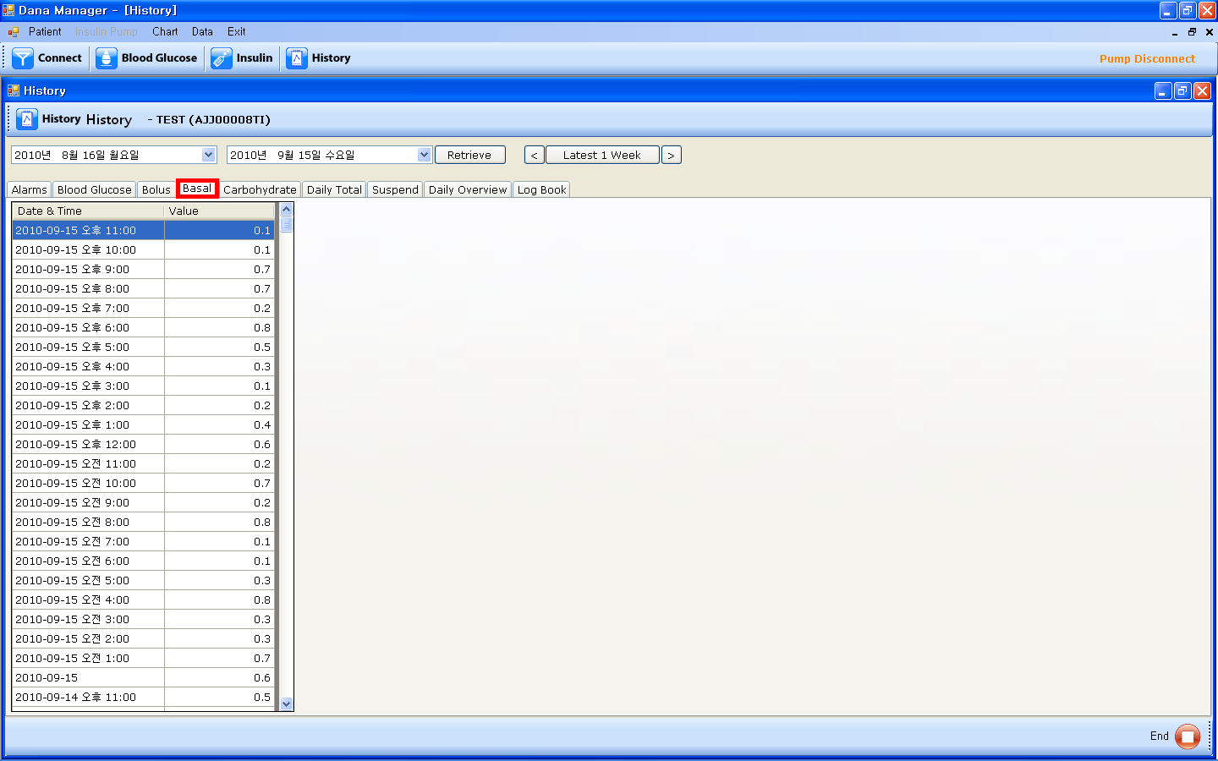

- It’s a history table of hourly basal insulin amount.
- If you click “Date & Time” on the top of the table, the data will be sorted by date and time in descending order.
- If you click “Value”, the data will be sorted by basal insulin amount in descending order.

- Carbohydrate
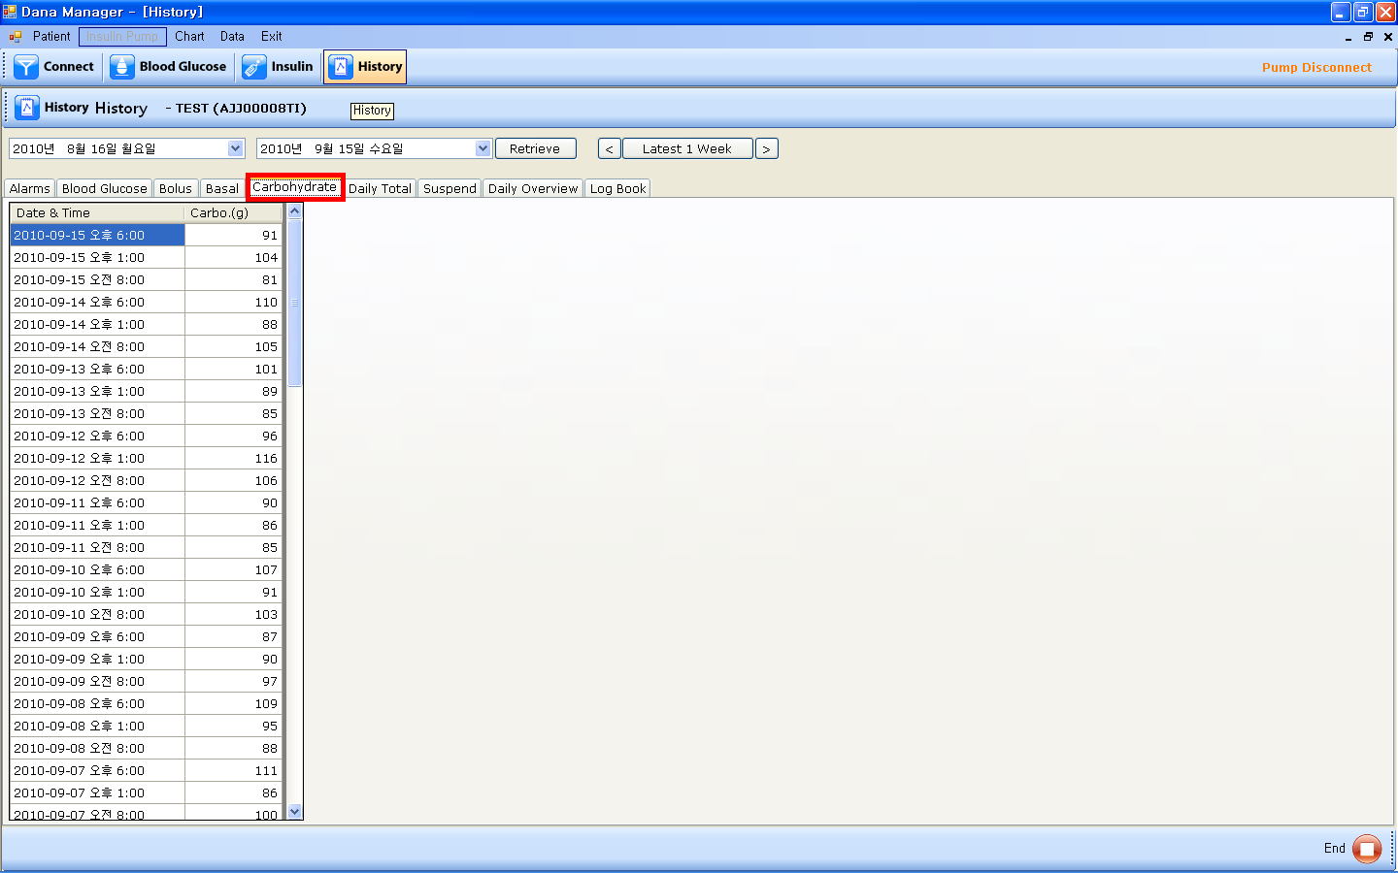

- It’s a history table of carbohydrate amounts.
- If you click “Date & Time” on the top of the table, the data will be sorted by date and time in descending order.
- If you click “Carbo(g)”, the data will be sorted by basal insulin amount in descending order.

- Daily Total
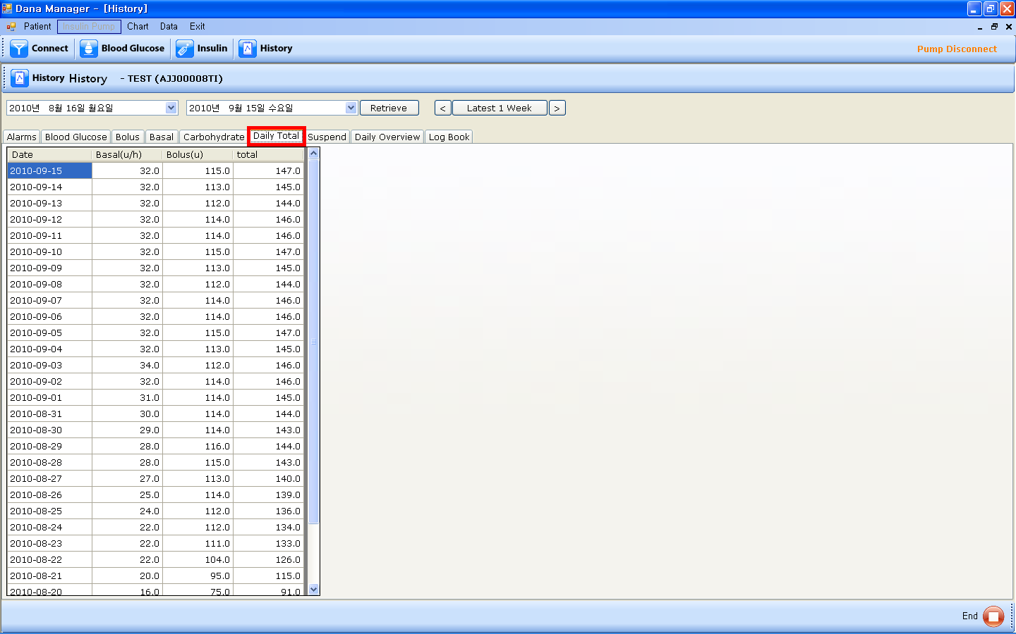

- It’s a history table of the daily total insulin amount delivered. You can find the daily total amount of basal insulin, daily total amount of meal bolus insulin, and daily total insulin amount.
- If you click “Date & Time” on the top of the table, the data will be sorted by date and time in descending order.
- If you click “Basal(u/h)”, the data will be sorted by total basal insulin amount in descending order.
- If you click “Bolus(u)”, the data will be sorted by total bolus insulin amount in descending order.
- If you click “Total”, the data will be sorted by daily total insulin amount in descending order.

- Suspend
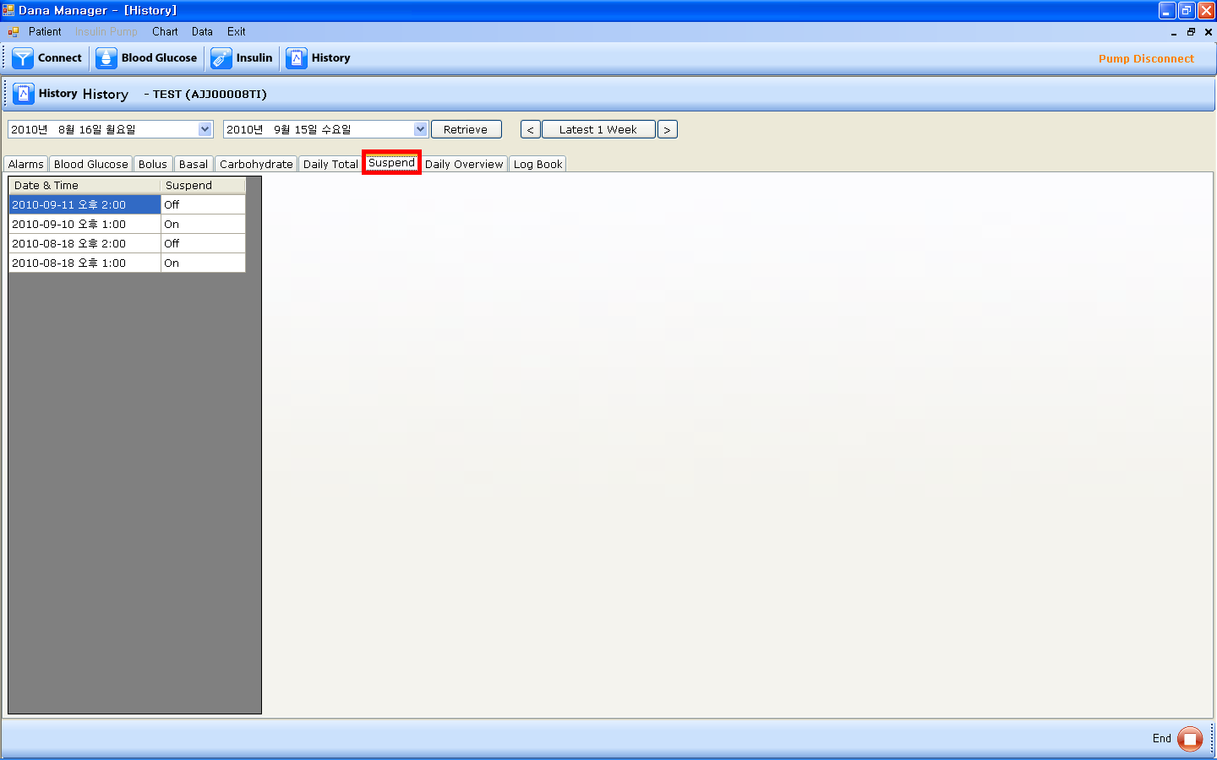

- It’s a history table of the time of suspend function is on or off.
- If you click “Date & Time” on the top of the table, the data will be sorted by date and time in descending order.

- Daily Overview
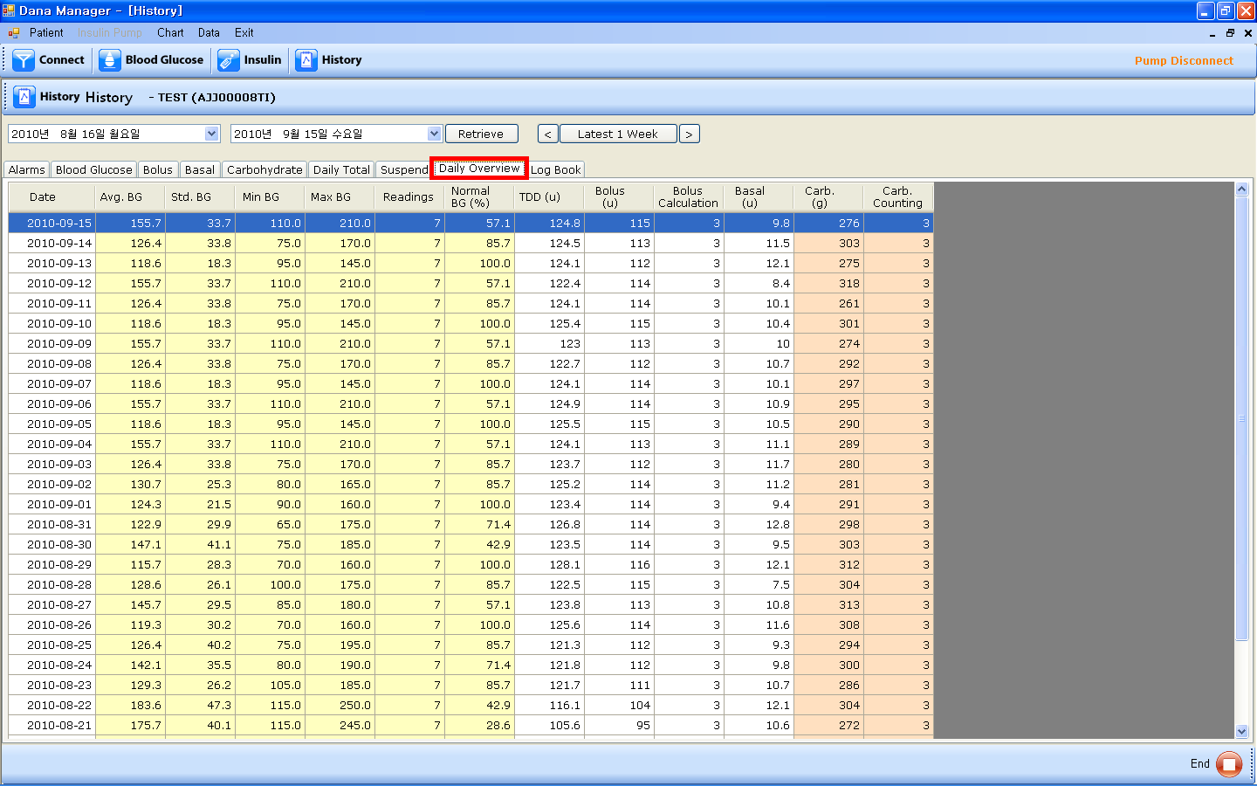

- It’s a table of daily summery of key factors.
- If you click “Date & Time” on the top of the table, the data will be sorted by date and time in descending order.
- “Avg. BG” column is the average value of your BG check results on that day.
- “Std. BG” column is the standard deviation of BG on that day.
- “Min BG” column is the minimum value of the BG check results on that day.
- “Max BG” column is the maximum value of the BG check results on that day.
- “Readings” column is the times of BG check on that day.
- “Normal BG(%)” is the percentage of the number of times being in the normal BG range out of the number of the total BG check times on that day.
- “TDD(u)” column is the total daily doses of insulin delivered on that day.
- “Bolus(u)” is the total insulin amount of the meal bolus insulin delivered on that day.
- “Bolus Calculation” column is the number of bolus calculating times on that day.
- “Basal(u)” column is the total insulin amount of the basal insulin delivered on that day.
- “Carb.(g)” column is the total grams of carbohydrates on that day.
- “Carb. Counting” column is the number of carbohydrate counting times on that day.

- Log Book
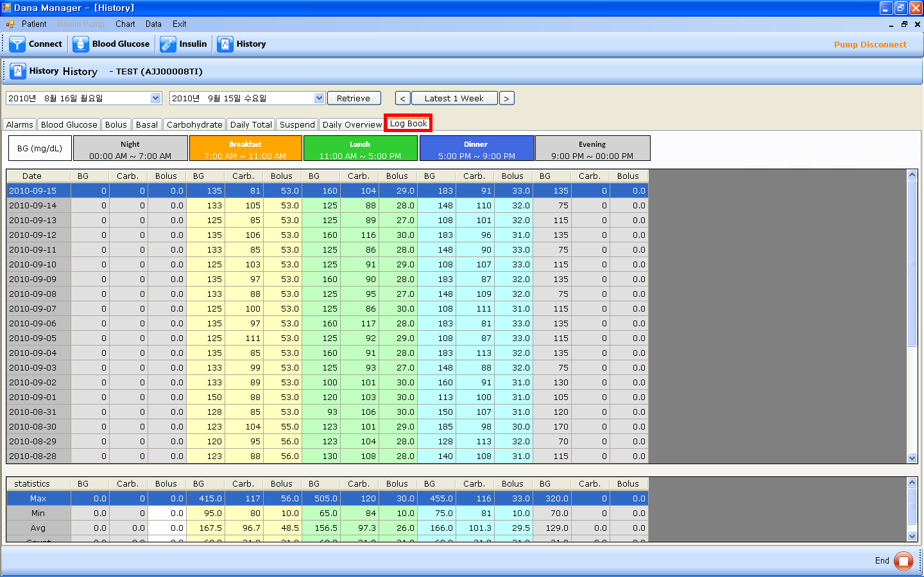

- It’s a log book divided in the time periods of Night, Breakfast, Lunch, Dinner, and Evening.
- If you click “Date”, the data will be sorted by date in descending order.
- “BG” column is BG value during the time period. If you check your BG value more than one time in that time period, “BG” column shows the average of the BG values in that time period.
- “Carb.” column is the grams of carbohydrate in that time period.
- “Bolus” column is the meal bolus insulin delivered in that time period.
- Statistics table shows Minimum value, Maximum value, Average value and the number of count in each column in that time period.

Chapter4. mENU bAR

- Patient

- New
- If you click “New” in the “Patient” menu, a pop-up screen will be shown up. Please fill in the required information of Serial No, Port, and User Info.

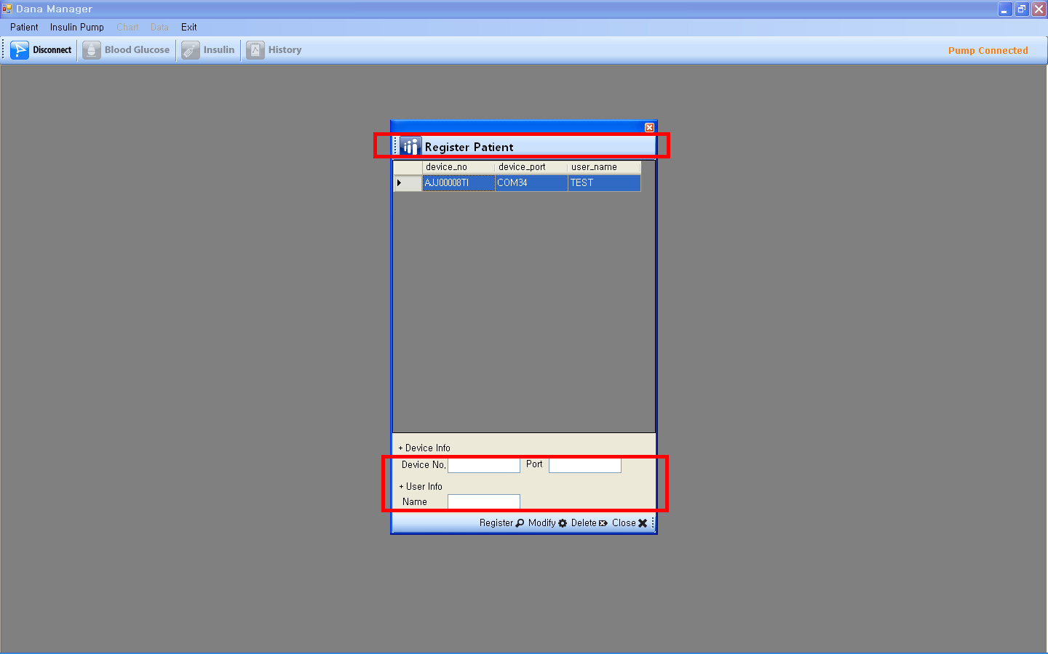

- List
- If you want to open the data of another patient, please click “List” and choose a patient and chick “Select” on the bottom.
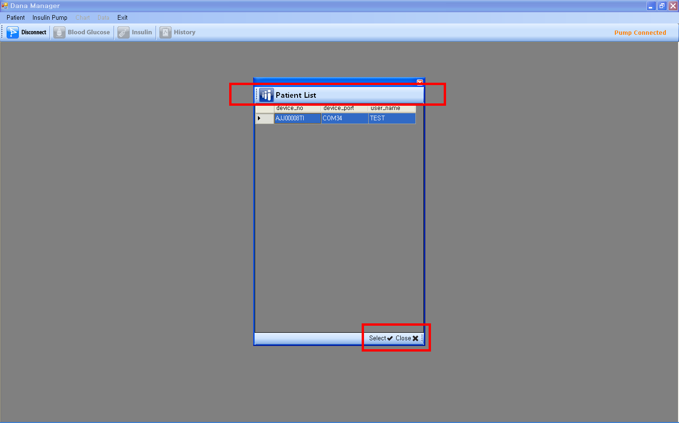

- Insulin Pump

“Insulin Pump” menu is activated only the pump is connected to your PC. If “Insulin Pump” menu is not activated, please click “Connect” icon.

- Disconnect
- If you want to disconnect the pump with your PC, please click “Disconnect” menu.

- History Download
- If you want to down load newly from the pump, please click “History Download” menu and a pop-up screen will show up. Please click “Download” on the bottom to start this feature.
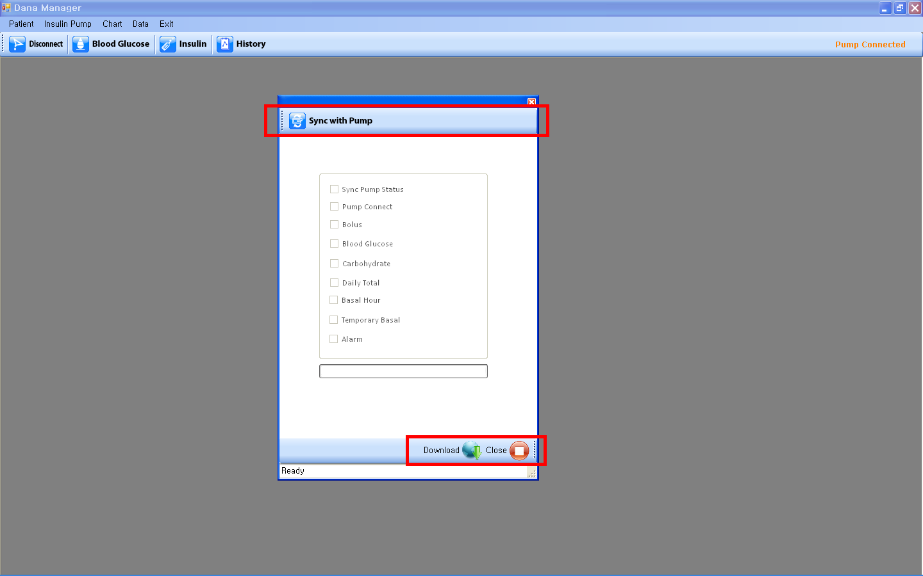

- Pump Status
- If you want to check the information regarding the pump, please click “Pump Status” menu and a pop-up screen will show up. You can find remained insulin, current time, total daily dose delivered today, basal dose, serial number, country name, and date.
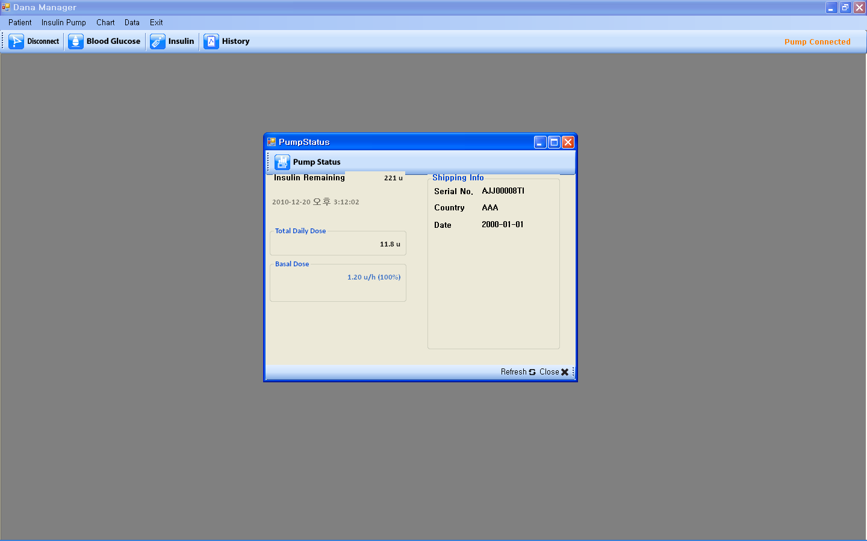

- Setting
- Bolus Setting
- If you click “Bolus Setting” menu, Setting Bolus screen will show up. You can set the insulin amount of the preset bolus.
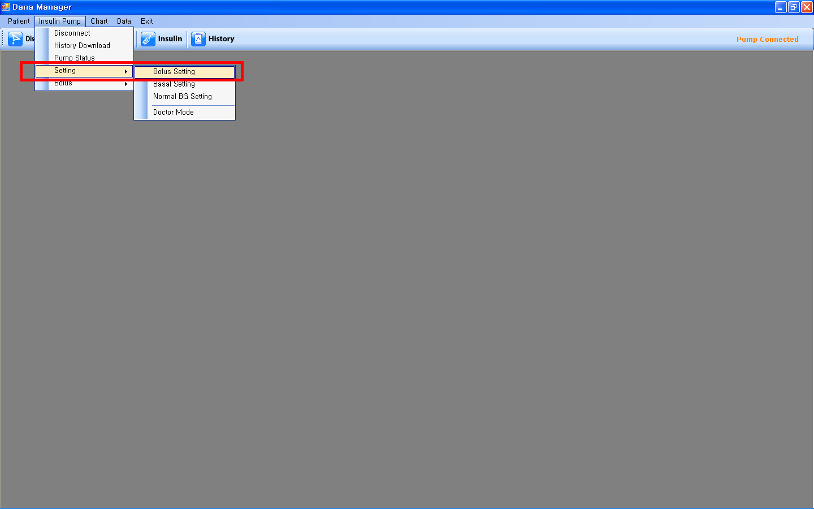
- Once you adjust the amount, please click “Apply” on the bottom to save it.
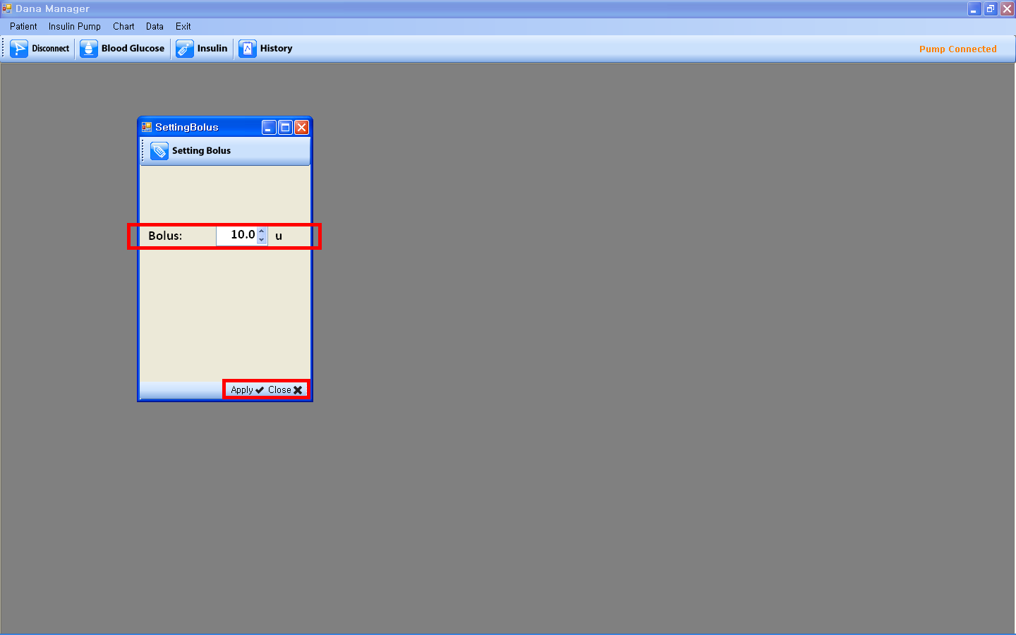

- Basal Setting
- If you click “Basal Setting”, Setting Basal screen will show up.
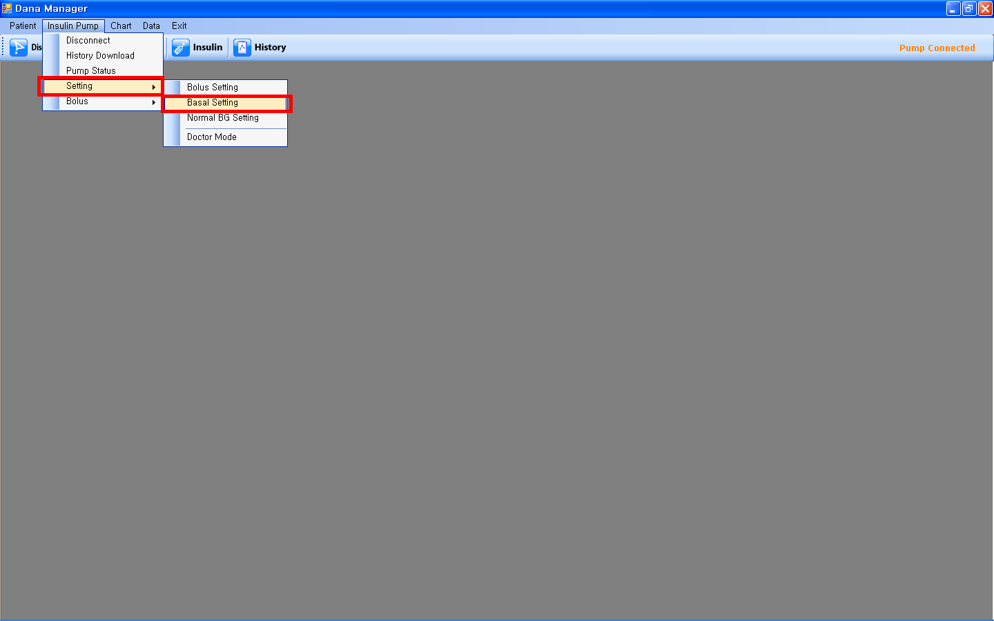

- Please select profile number on the top first and then adjust the basal insulin amount hourly. Please click “Apply” on the bottom to save it.
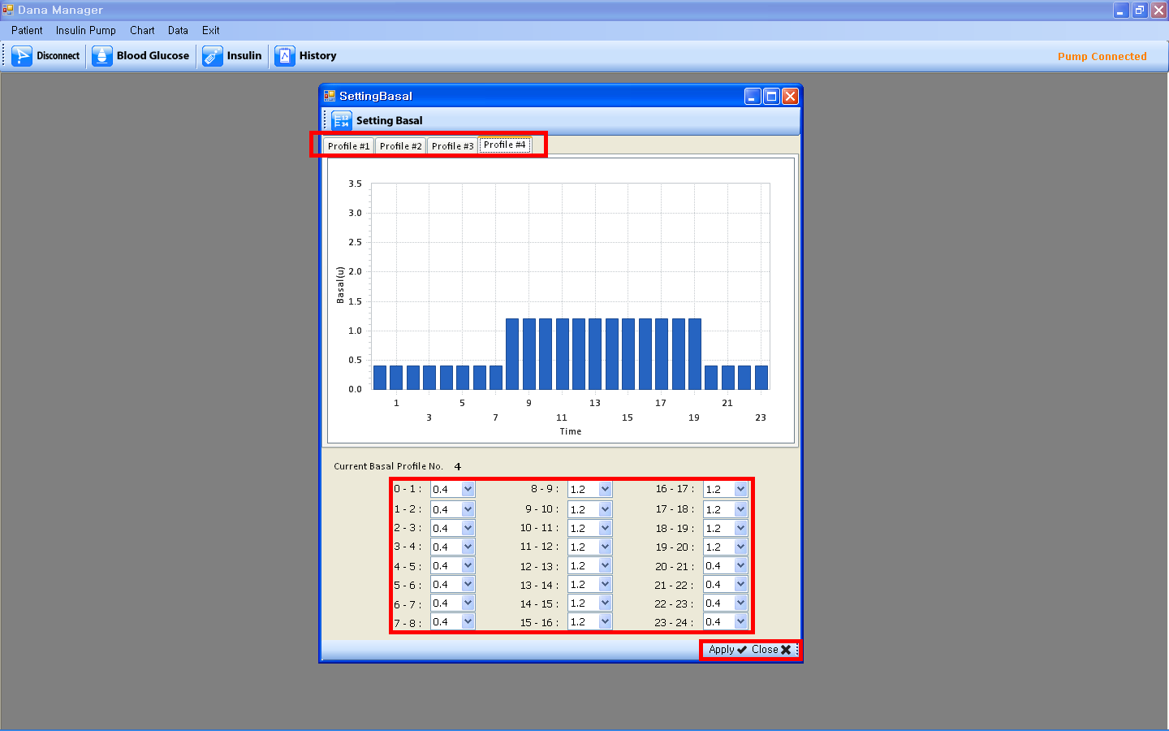

- Normal BG Setting
- If you click “Normal BG Setting”, BG Zone screen will show up.
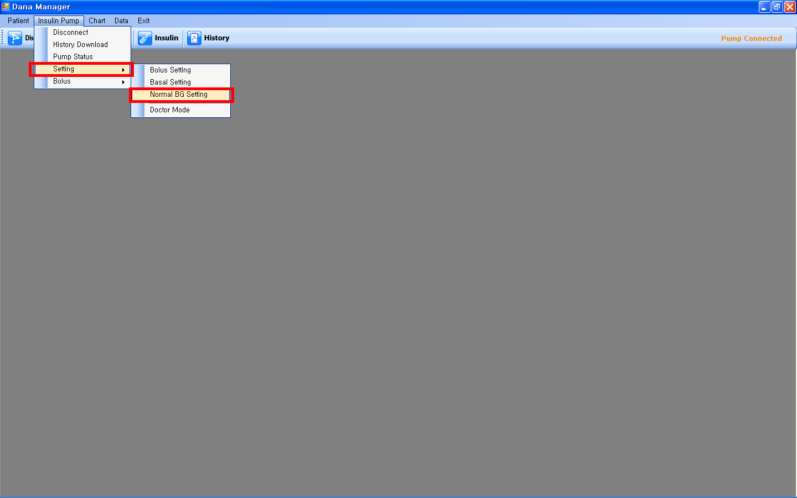
- Please adjust the values of Normal High and Normal Low and click the “Apply” on the bottom to save it.
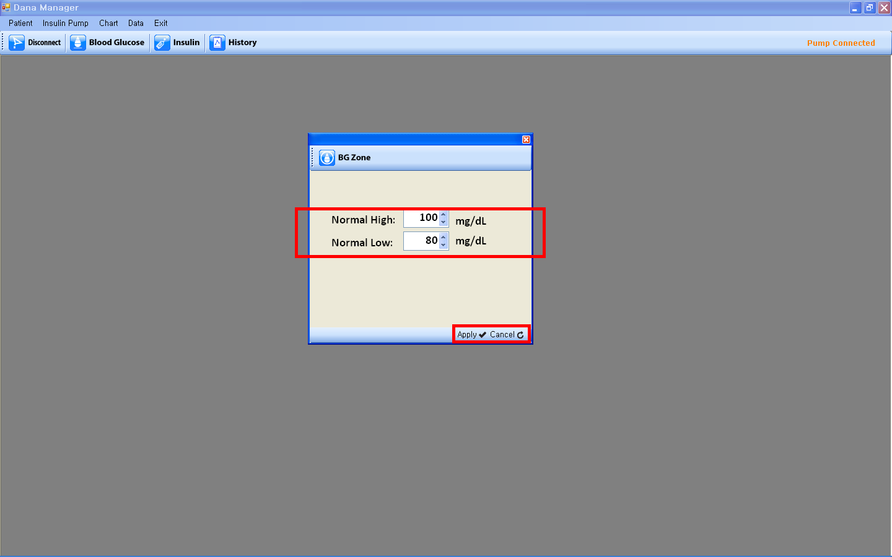

- Bolus
- Bolus
- If you click “Bolus” menu,
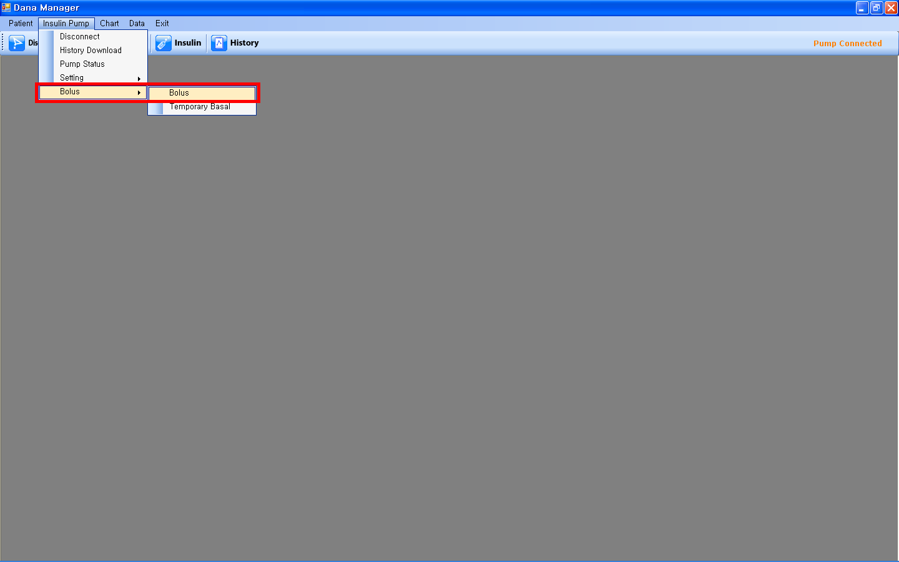

- Please fill in the required information to calculate the suggested bolus insulin.
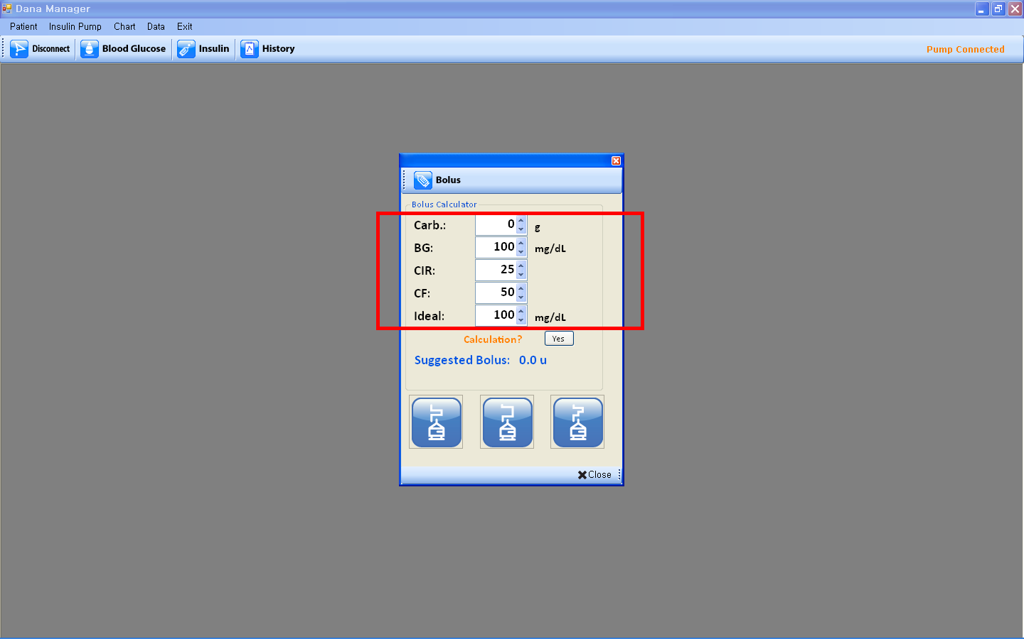
- After adjusting values, please click “Yes”, then you can find the Suggested Bolus units. And choose one bolus type out of step bolus, extended bolus and dual pattern bolus.
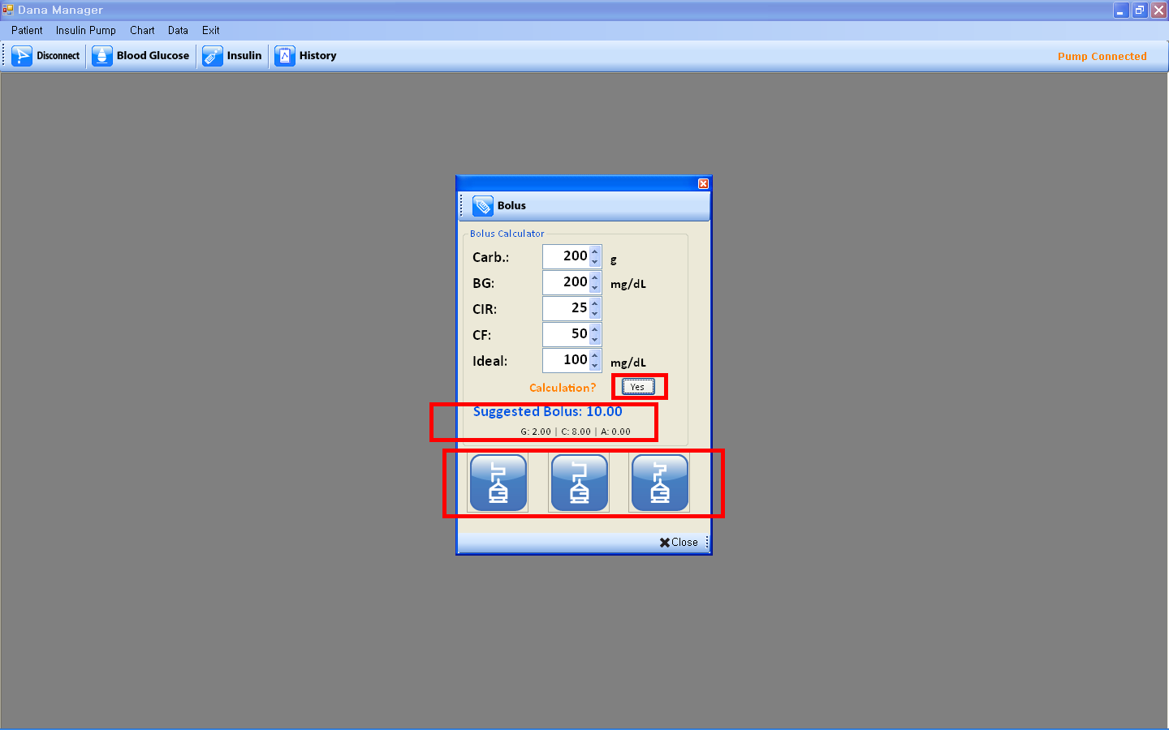
- Once the pop-up screen of the bolus type, please check the insulin amount and then click “Start” on the bottom to start bolus delivery in the pump. If you want to change the insulin amount, please adjust the insulin amount and click “Start”.
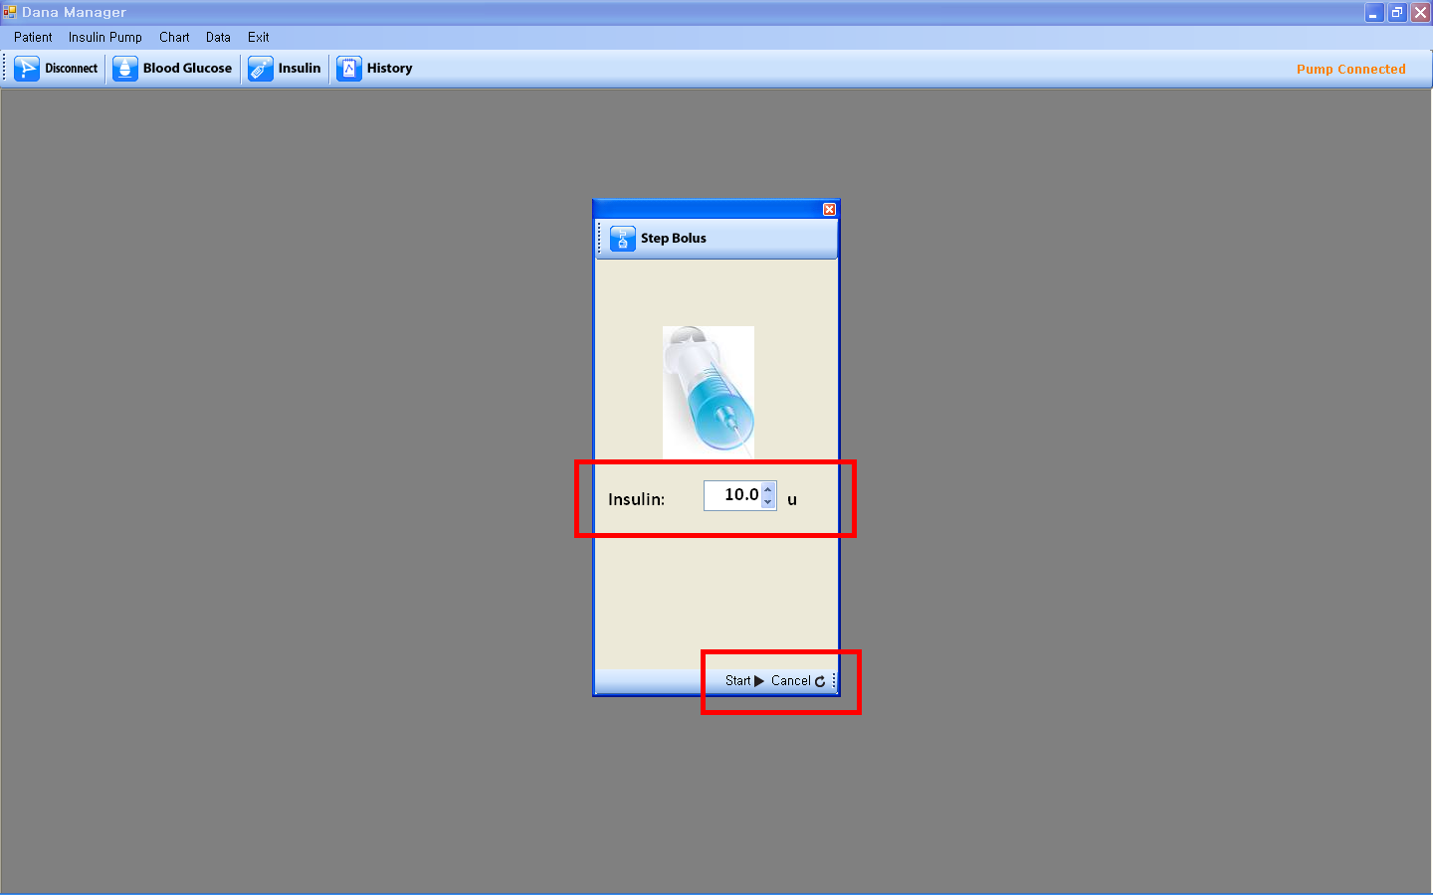

- Temporary Basal
- If you click “Temporary Basal”, Temporary Basal screen will show up.
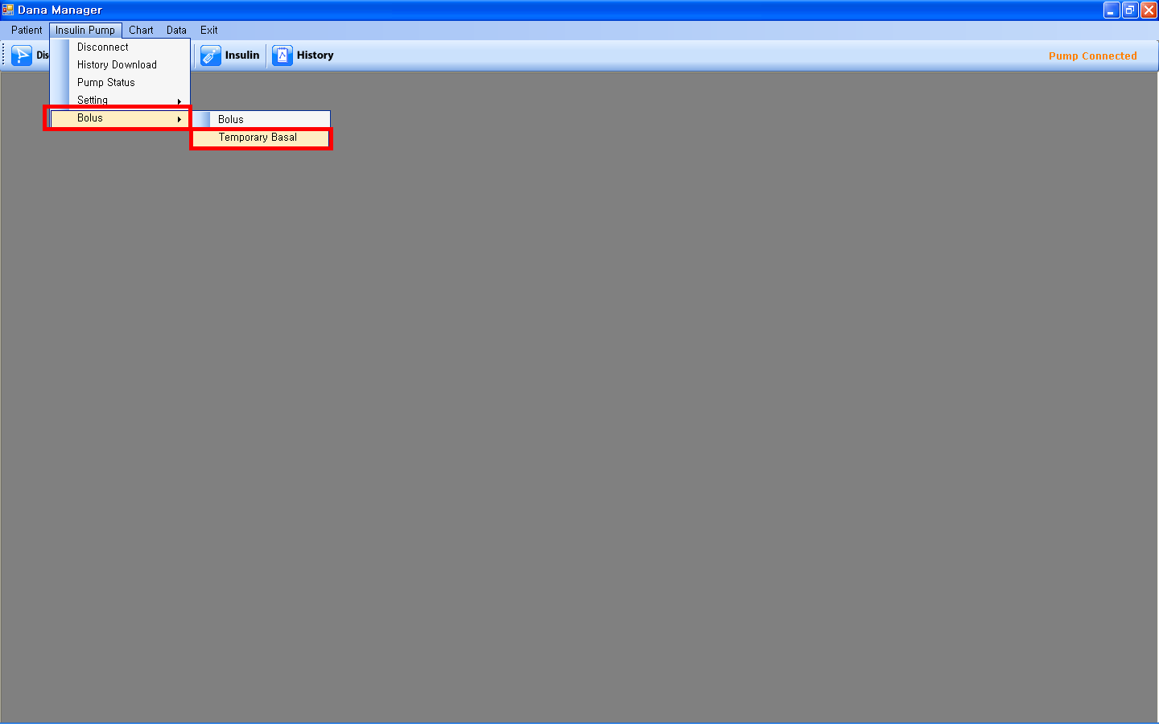

- Please fill in Duration and Ratio, and click “Start” at the bottom to start it.
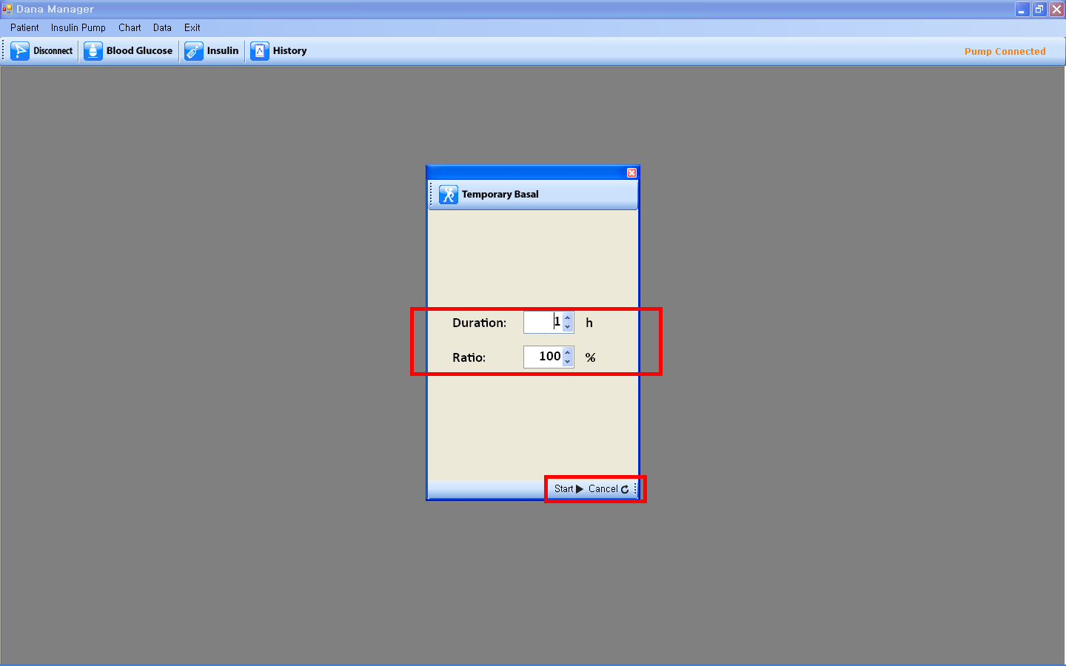

- Chart

- Blood Glucose
- Click of “Blood Glucose” menu is the same with a click of “Blood Glucose” icon. Please see Chapter 3. Function > III. Blood Glucose for detail.

- Insulin
- Click of “Insulin” menu is the same with a click of “Insulin” icon. Please see Chapter 3. Function > IV. Insulin for detail.

- Data

- History
- Click of “History” menu is the same with a click of “History” icon. Please see Chapter 3. Function > V. History for detail.
- Upload
- If you click “Upload”, you can upload the data into DANA website (www.dana-diabecare.com) in order for you to review the data at anytime, anywhere. (This feature is not available at this moment. DANA website will be open soon)

- Exit
You can exit the DANA Manager.

